Metody numeryczne

*Badanie wskaźnika giełdowego MACD*

# Jakub Bronowski, 193208, gr. 2

## 11.03.2024 r.

Spis treści

Wstęp 2

Wyznaczanie wskaźnika MACD 2

Implementacja rozwiązania 2

Analizowane walory 3

Wnioski ogólne 3

Analiza poszczególnych instrumentów finansowych 4

WIG20, D1 4

WIG20, W1 7

EURPLN, D1 10

EURPLN, W1 13

S&P500, D1 16

S&P500, W1 19

Orlen Spółka Akcyjna, D1 22

Orlen Spółka Akcyjna, W1 25

Skumulowane zestawienie zysku/straty 28

Algorytm zakupów i jego ewaluacja 28

Podsumowanie 28

### Wstęp

Wskaźnik MACD wykorzystuje się do przeprowadzania analizy technicznej danego waloru rynku finansowego. Nie ma ograniczeń dotyczących typu waloru, to jest: wskaźnik można wykorzystać zarówno przy analizie indeksów giełdowych, akcji, par walutowych, kryptowalut itp. MACD jest znany w świecie finansów od końcówki lat 70. XX wieku, pozwala na wyznaczenie zmian w domenie siły waloru, kierunku zmian ceny czy przewidywaniu zmiany trendu na danym instrumencie finansowym. Jego siła drzemie w użytych przy jego obliczeniach wykładniczych średnich kroczących (ang. exponential moving average, *EMA*) wyliczanych dla N wartości wstecz. Poprzez odpowiednie dobranie wartości N jesteśmy w stanie przy niedużym nakładzie obliczeń wyznaczyć linie sygnałowe i MACD, których przecięcia wygenerują sygnał kupna lub sprzedaży waloru (*BUY/SELL signal)*.

### Wyznaczanie wskaźnika MACD

Na wskaźnik MACD składają się dwie linie, MACD i SIGNAL. Przecięcie tychże linii generuje sygnał *BUY/SELL* w następujący sposób:

1. sygnał *BUY* pojawi się zawsze, gdy linia MACD przetnie linię SIGNAL od dołu, zapowiada to nastanie trendu wzrostowego, czyli warto zakupić walor.
2. sygnał *SELL* pojawi się zawsze, gdy linia MACD przetnie linię SIGNAL od góry, prawdopodobnie nadchodzi zmiana trendu, należy realizować zysk lub chronić kapitał.

Do wyznaczenia linii MACD wykorzystuje się różnicę między średnimi EMA12 i EMA26, gdzie liczba w indeksie dolnym oznacza ilość wartości wstecz, które należy uwzględnić w obliczeniach. Linię SIGNAL tworzy średnia EMA9 wyliczana z posiadanych już wartości linii MACD. Niniejsze rozwiązanie uwzględnia zmiany waloru w ujęciu 9/12/26 interwałów, co pozwala uwzględniać krótkoterminowe wahania cen jak i dłuższy trend naraz. Wypadałoby zadać pytanie jak dużą wagę mają zmiany krótkoterminowe? Odpowiedź przedstawiona została poniżej, przy omówieniu badanych walorów.

Warto wspomnieć, że – tak jak każdy wskaźnik maklerski – MACD jest narażone na zjawisko *false positives*, które eliminujemy albo poprzez równoległą obserwację innych wskaźników giełdowych albo manipulacje czasu trwania inwestycji albo inwestowanie w walory obdarzone dużym zaufaniem, to jest: rozgrywane technicznie a nie spekulacyjnie. W niniejszej pracy przedstawione zostaną dwie ostatnie strategie.

### Implementacja rozwiązania

Program analizujący instrumenty finansowe napisany został w języku *Python* przy wykorzystaniu bibliotek *pandas* (przetwarzanie danych wejściowych) oraz *matplotlib* (generowanie wykresów). Danych do analizy dumnie dostarczył serwis giełdowy [stooq.pl](https://stooq.pl/). Zestawienia zysków i strat w formacie tabeli w konsoli wytworzył autor pracy. Pracę z programem rozpoczynamy od importu danych z pliku CSV a następnie wywołujemy funkcję *worker(dane, nazwa waloru, interwał, flaga wyświetlania wykresu)*.

### Analizowane walory

Walory podane analizie różnią się typem, pochodzeniem, notowanym obrotem. Do analizy wybrano:

1. polski indeks giełdowy *WIG20*,
2. parę walutową *EURPLN*,
3. amerykański indeks giełdowy *S&P500,*
4. akcje *Orlen Spółka Akcyjna* (symbol GPW: *PKN*)

WIG20 – 20 największych spółek notowanych na GPW.  
S&P500 – top 500 spółek pod względem kapitalizacji notowanych na NYSE i NASDAQ.  
EURPLN – kurs wymiany walut na międzynarodowym rynku FOREX.  
Orlen Spółka Akcyjna – polski koncern multienergetyczny zajmujący się głównie petrochemią.

Różnorodność walorów ma pomóc w określeniu użyteczności wskaźnika przy analizie technicznej. Walory cechują się różną odpornością na spekulacje, dostępnością, zmiennością, płynnością, ilością zainwestowanego kapitału czy siłą rynku, na którym są notowane.

Każdy z walorów analizuje się łącznie na 2000 rekordach, co rozumiemy jako 1000 próbek zbieranych w interwałach odpowiednio 1 dnia *(D1)* i1 tygodnia *(W1).* Wycena waloru to cena zamknięcia waloru w dniu, w którym pobrano próbkę danych.

### Wnioski ogólne

Można stwierdzić, że z niemalże 100% dokładnością sygnały kupna *(BUY)* znajdują się tuż za dołkiem na wykresie ceny waloru. Również bardzo dokładnie wskaźnik MACD umieszcza sygnał sprzedaży *(SELL)*, są one za szczytami – czasem w dość dalekiej odległości. Warto odnotować, że sygnał sprzedaży może pojawić się przy kursie niższym niż cena obecna przy ostatnim sygnale kupna. W tych sytuacjach miała miejsce zmiana trendu, opłacało się ponieść stratę i opuścić walor, ażeby nie tracić więcej kapitału. W badanych interwałach czasu widać też, że im większy obrót na walorze, tym więcej sygnałów *BUY/SELL* pojawia się na wykresie.

Wykorzystanie średnich kroczących sprawia, że niemożliwym jest wygenerowanie sygnału *BUY/SELL* bezpośrednio w dołku (lub bardzo bliskich odległościach od minimum lokalnego), zawsze kupimy trochę drożej niż najniższa cena w danym okresie. Nie inaczej sytuacja wygląda w przypadku szczytów. Sygnał *SELL* zawsze jest za szczytem. Natomiast można zaobserwować ciekawą rzecz – im mniejsze wahania kursu, tym gęściej sygnałów na wykresie i są one bliżej maksymalnych dołków i górek cen waloru w przedziałach dat. Nasuwa się myśl, że dla inwestycji średnio- lub długoterminowych wskaźnik MACD sprawia się lepiej niż dla krótkoterminowych oraz dla aktywów o niegwałtownych wahaniach kursu. Niniejsze obserwacje zaznaczono na wykresach przedstawionych poniżej wraz z wyszczególnieniem dużych błędów dowodzących, że MACD działa nieoptymalnie w przypadku transakcji kupna (zielone kropki) i sprzedaży (czerwone kropki). Dla walorów w interwale D1 podano daty poważniejszych błędów. Transakcje typu *ochrona kapitału* wytłuszczono i zapisano kursywą w zestawieniach transakcji. Transakcje pogrubione to transakcje stratne.

### Analiza poszczególnych instrumentów finansowych

### WIG20, D1

Wykres 1.

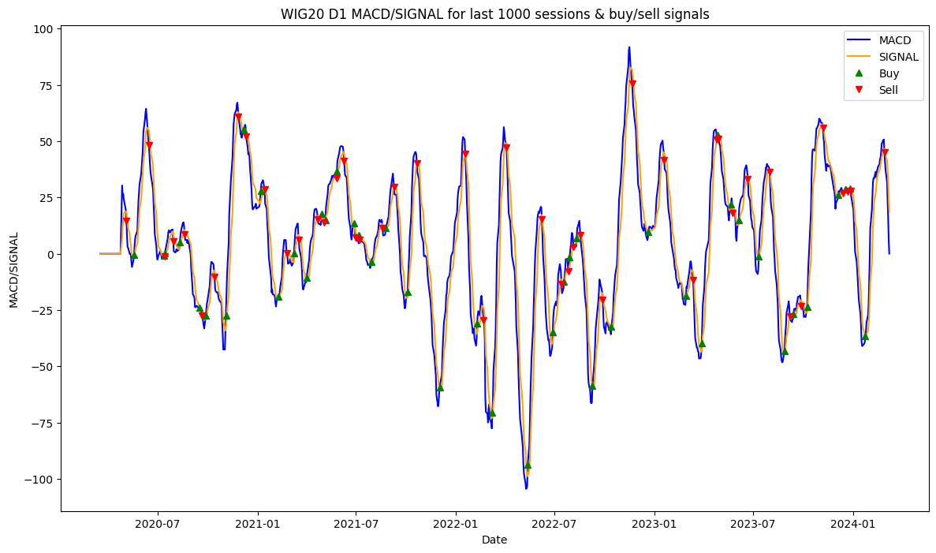Cena WIG20 w interwale D1 w czasie 18.03.2020 – 08.03.2024 (1000 sesji)

Wykres 2.

Linie MACD i SIGNAL dla WIG20 w interwale D1 wraz z zaznaczonymi sygnałami *BUY/SELL.*

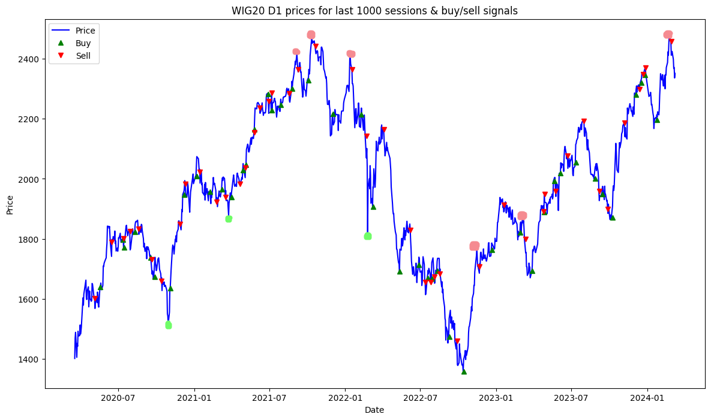

Wykres 3.

Cena WIG20 w interwale D1 wraz z zaznaczonymi sygnałami *BUY/SELL*.

Lepsze kupno:

1. ostatnie dni października 2020 r.
2. ostatnie dni marca 2021 r.
3. 24.02.2022 r.

Lepsza sprzedaż:

1. początek września 2021 r.
2. 12.10.2021 r.
3. 15.11.2022 r.
4. 10.01.2023 r.

Ochrona kapitału:

1. luty – marzec 2021 r.
2. luty 2022 r.
3. czerwiec 2022 r.
4. sierpień - wrzesień 2022 r.
5. druga połowa września i początek października 2023 r.

|  |
| --- |
| =========================================================================================================================================================  Profit/loss report for WIG20 D1; transaction every BUY/SELL signal (at least D1 apart, if bought, need to be sold).  Buy date: 2020-05-19 | Buy price: 1639.08 | Sell date: 2020-06-15 | Sell price: 1788.83 | Profit: 149750.00 9.136 % | Duration: 27 days 00:00:00  Buy date: 2020-07-13 | Buy price: 1797.27 | Sell date: 2020-07-14 | Sell price: 1801.64 | Profit: 4370.00 0.243 % | Duration: 1 days 00:00:00  Buy date: 2020-07-15 | Buy price: 1771.70 | Sell date: 2020-07-30 | Sell price: 1824.53 | Profit: 52830.00 2.982 % | Duration: 15 days 00:00:00  Buy date: 2020-08-11 | Buy price: 1823.15 | Sell date: 2020-08-20 | Sell price: 1833.22 | Profit: 10070.00 0.552 % | Duration: 9 days 00:00:00  **Buy date: 2020-09-17 | Buy price: 1738.10 | Sell date: 2020-09-21 | Sell price: 1731.76 | Profit: -6340.00 -0.365 % | Duration: 4 days 00:00:00**  **Buy date: 2020-09-28 | Buy price: 1674.14 | Sell date: 2020-10-14 | Sell price: 1660.12 | Profit: -14020.00 -0.837 % | Duration: 16 days 00:00:00**  Buy date: 2020-11-04 | Buy price: 1636.28 | Sell date: 2020-11-27 | Sell price: 1849.57 | Profit: 213290.00 13.035 % | Duration: 23 days 00:00:00  Buy date: 2020-12-07 | Buy price: 1947.68 | Sell date: 2020-12-11 | Sell price: 1984.00 | Profit: 36320.00 1.865 % | Duration: 4 days 00:00:00  Buy date: 2021-01-07 | Buy price: 2009.12 | Sell date: 2021-01-14 | Sell price: 2023.36 | Profit: 14240.00 0.709 % | Duration: 7 days 00:00:00  ***Buy date: 2021-02-08 | Buy price: 1957.73 | Sell date: 2021-02-24 | Sell price: 1922.59 | Profit: -35140.00 -1.795 % | Duration: 16 days 00:00:00***  ***Buy date: 2021-03-09 | Buy price: 1965.25 | Sell date: 2021-03-18 | Sell price: 1939.01 | Profit: -26240.00 -1.335 % | Duration: 9 days 00:00:00***  Buy date: 2021-04-01 | Buy price: 1938.84 | Sell date: 2021-04-22 | Sell price: 1982.40 | Profit: 43560.00 2.247 % | Duration: 21 days 00:00:00  Buy date: 2021-04-29 | Buy price: 2029.64 | Sell date: 2021-05-04 | Sell price: 2037.59 | Profit: 7950.00 0.392 % | Duration: 5 days 00:00:00  Buy date: 2021-05-06 | Buy price: 2047.36 | Sell date: 2021-05-26 | Sell price: 2153.78 | Profit: 106420.00 5.198 % | Duration: 20 days 00:00:00  Buy date: 2021-05-27 | Buy price: 2164.89 | Sell date: 2021-06-09 | Sell price: 2237.61 | Profit: 72720.00 3.359 % | Duration: 13 days 00:00:00  **Buy date: 2021-06-28 | Buy price: 2282.46 | Sell date: 2021-06-30 | Sell price: 2258.24 | Profit: -24220.00 -1.061 % | Duration: 2 days 00:00:00**  Buy date: 2021-07-07 | Buy price: 2228.46 | Sell date: 2021-07-08 | Sell price: 2285.79 | Profit: 57330.00 2.573 % | Duration: 1 days 00:00:00  Buy date: 2021-07-29 | Buy price: 2245.76 | Sell date: 2021-08-19 | Sell price: 2284.97 | Profit: 39210.00 1.746 % | Duration: 21 days 00:00:00  Buy date: 2021-08-25 | Buy price: 2300.90 | Sell date: 2021-09-09 | Sell price: 2364.63 | Profit: 63730.00 2.770 % | Duration: 15 days 00:00:00  Buy date: 2021-10-04 | Buy price: 2327.88 | Sell date: 2021-10-21 | Sell price: 2443.11 | Profit: 115230.00 4.950 % | Duration: 17 days 00:00:00  Buy date: 2021-12-02 | Buy price: 2217.18 | Sell date: 2022-01-18 | Sell price: 2365.29 | Profit: 148110.00 6.680 % | Duration: 47 days 00:00:00  ***Buy date: 2022-02-09 | Buy price: 2215.12 | Sell date: 2022-02-21 | Sell price: 2143.28 | Profit: -71840.00 -3.243 % | Duration: 12 days 00:00:00***  Buy date: 2022-03-09 | Buy price: 1908.10 | Sell date: 2022-04-04 | Sell price: 2164.81 | Profit: 256710.00 13.454 % | Duration: 26 days 00:00:00  Buy date: 2022-05-13 | Buy price: 1691.62 | Sell date: 2022-06-08 | Sell price: 1828.57 | Profit: 136950.00 8.096 % | Duration: 26 days 00:00:00  ***Buy date: 2022-06-28 | Buy price: 1713.18 | Sell date: 2022-07-14 | Sell price: 1655.65 | Profit: -57530.00 -3.358 % | Duration: 16 days 00:00:00***  **Buy date: 2022-07-19 | Buy price: 1669.48 | Sell date: 2022-07-27 | Sell price: 1654.70 | Profit: -14780.00 -0.885 % | Duration: 8 days 00:00:00**  Buy date: 2022-07-29 | Buy price: 1667.17 | Sell date: 2022-08-05 | Sell price: 1674.37 | Profit: 7200.00 0.432 % | Duration: 7 days 00:00:00  ***Buy date: 2022-08-11 | Buy price: 1694.11 | Sell date: 2022-08-18 | Sell price: 1682.93 | Profit: -11180.00 -0.660 % | Duration: 7 days 00:00:00***  ***Buy date: 2022-09-09 | Buy price: 1473.18 | Sell date: 2022-09-28 | Sell price: 1458.81 | Profit: -14370.00 -0.975 % | Duration: 19 days 00:00:00***  Buy date: 2022-10-14 | Buy price: 1358.50 | Sell date: 2022-11-21 | Sell price: 1707.23 | Profit: 348730.00 25.670 % | Duration: 38 days 00:00:00  Buy date: 2022-12-21 | Buy price: 1763.20 | Sell date: 2023-01-19 | Sell price: 1913.25 | Profit: 150050.00 8.510 % | Duration: 29 days 00:00:00  **Buy date: 2023-02-28 | Buy price: 1820.79 | Sell date: 2023-03-13 | Sell price: 1799.58 | Profit: -21210.00 -1.165 % | Duration: 13 days 00:00:00**  Buy date: 2023-03-29 | Buy price: 1694.12 | Sell date: 2023-04-26 | Sell price: 1890.69 | Profit: 196570.00 11.603 % | Duration: 28 days 00:00:00  Buy date: 2023-04-27 | Buy price: 1888.61 | Sell date: 2023-04-28 | Sell price: 1948.07 | Profit: 59460.00 3.148 % | Duration: 1 days 00:00:00  **Buy date: 2023-05-22 | Buy price: 1992.31 | Sell date: 2023-05-25 | Sell price: 1958.63 | Profit: -33680.00 -1.690 % | Duration: 3 days 00:00:00**  Buy date: 2023-06-05 | Buy price: 2018.09 | Sell date: 2023-06-22 | Sell price: 2076.16 | Profit: 58070.00 2.877 % | Duration: 17 days 00:00:00  Buy date: 2023-07-12 | Buy price: 2054.39 | Sell date: 2023-08-01 | Sell price: 2193.56 | Profit: 139170.00 6.774 % | Duration: 20 days 00:00:00  ***Buy date: 2023-08-28 | Buy price: 2000.42 | Sell date: 2023-09-07 | Sell price: 1958.07 | Profit: -42350.00 -2.117 % | Duration: 10 days*** *00:00:00*  ***Buy date: 2023-09-14 | Buy price: 1949.65 | Sell date: 2023-09-28 | Sell price: 1898.92 | Profit: -50730.00 -2.602 % | Duration: 14 days*** *00:00:00*  Buy date: 2023-10-09 | Buy price: 1870.43 | Sell date: 2023-11-07 | Sell price: 2186.01 | Profit: 315580.00 16.872 % | Duration: 29 days 00:00:00  Buy date: 2023-12-05 | Buy price: 2281.04 | Sell date: 2023-12-14 | Sell price: 2298.31 | Profit: 17270.00 0.757 % | Duration: 9 days 00:00:00  Buy date: 2023-12-18 | Buy price: 2320.45 | Sell date: 2023-12-22 | Sell price: 2348.67 | Profit: 28220.00 1.216 % | Duration: 4 days 00:00:00  Buy date: 2023-12-27 | Buy price: 2346.70 | Sell date: 2023-12-28 | Sell price: 2371.28 | Profit: 24580.00 1.047 % | Duration: 1 days 00:00:00  Buy date: 2024-01-24 | Buy price: 2196.27 | Sell date: 2024-02-28 | Sell price: 2457.83 | Profit: 261560.00 11.909 % | Duration: 35 days 00:00:00  =========================================================================================================================================================  Total earnings: 2711620.0 generated using 1639080 units of borrowed capital, which needs to be returned  Return on Investment ROI: 65.435% |

Zestawienie transakcji kupna/sprzedaży co sygnał, interwał D1

### WIG20, W1

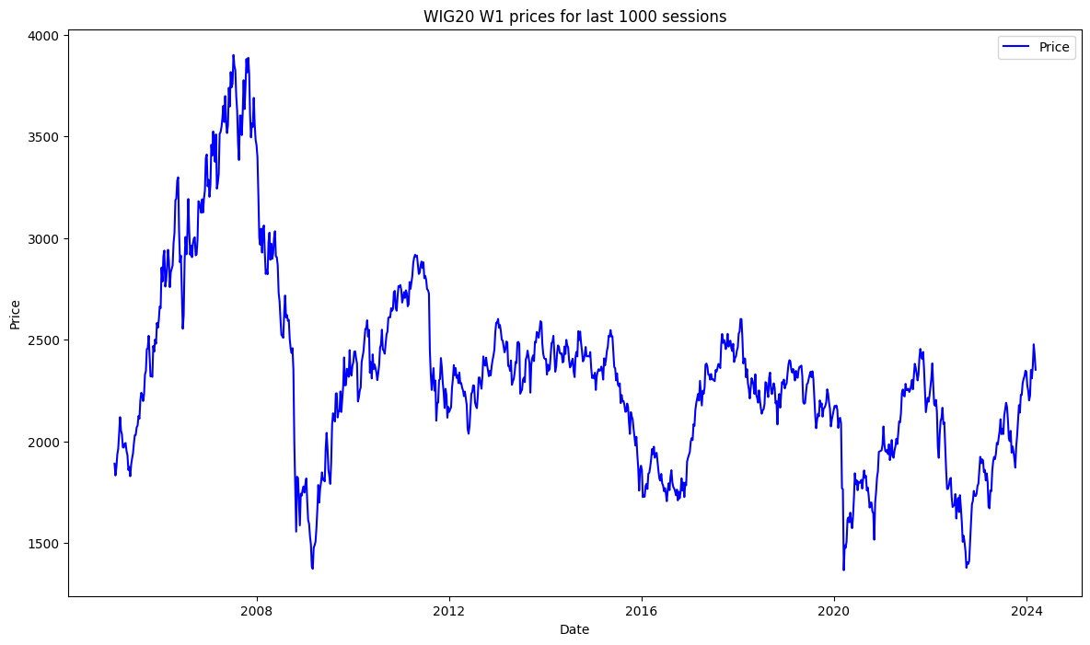

Wykres 4.

Cena WIG20 w interwale W1 w czasie 16.01.2005 – 08.03.2024 (1000 tygodni)

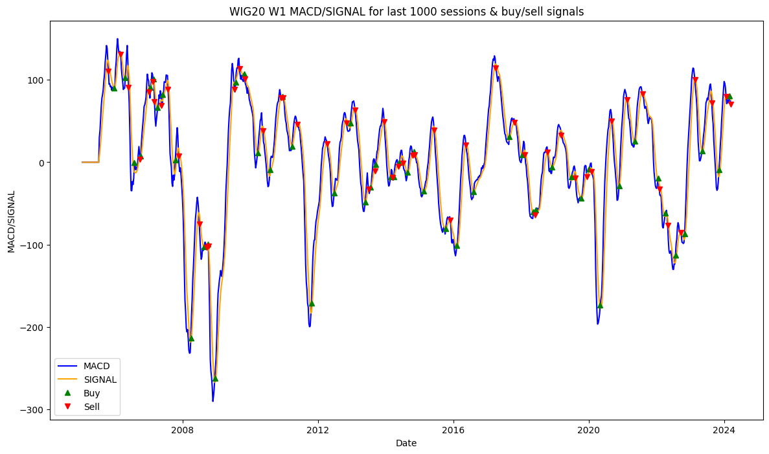

Wykres 5.

Linie MACD i SIGNAL dla WIG20 w interwale W1 wraz z zaznaczonymi sygnałami *BUY/SELL.*

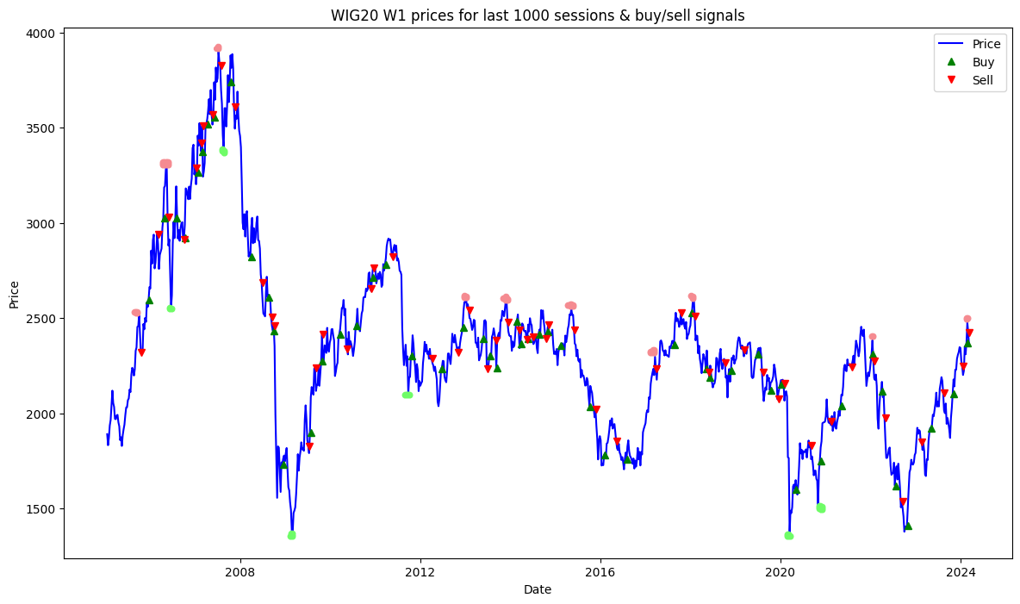

Wykres 6.

Cena WIG20 w interwale W1 wraz z zaznaczonymi sygnałami *BUY/SELL*.

|  |
| --- |
| =========================================================================================================================================================  Profit/loss report for WIG20 W1; transaction every BUY/SELL signal (at least W1 apart, if bought, need to be sold).  Buy date: 2005-12-25 | Buy price: 2596.16 | Sell date: 2006-03-05 | Sell price: 2941.38 | Profit: 345220.00 13.297 % | Duration: 70 days 00:00:00  Buy date: 2006-04-23 | Buy price: 3023.69 | Sell date: 2006-05-28 | Sell price: 3031.52 | Profit: 7830.00 0.259 % | Duration: 35 days 00:00:00  ***Buy date: 2006-07-30 | Buy price: 3024.01 | Sell date: 2006-10-01 | Sell price: 2914.20 | Profit: -109810.00 -3.631 % | Duration: 63 days 00:00:00***  Buy date: 2006-10-08 | Buy price: 2918.83 | Sell date: 2007-01-07 | Sell price: 3285.49 | Profit: 366660.00 12.562 % | Duration: 91 days 00:00:00  Buy date: 2007-01-21 | Buy price: 3262.98 | Sell date: 2007-02-18 | Sell price: 3417.38 | Profit: 154400.00 4.732 % | Duration: 28 days 00:00:00  Buy date: 2007-02-25 | Buy price: 3374.21 | Sell date: 2007-03-04 | Sell price: 3508.99 | Profit: 134780.00 3.994 % | Duration: 7 days 00:00:00  Buy date: 2007-04-08 | Buy price: 3520.24 | Sell date: 2007-05-20 | Sell price: 3568.93 | Profit: 48690.00 1.383 % | Duration: 42 days 00:00:00  Buy date: 2007-06-03 | Buy price: 3554.52 | Sell date: 2007-07-29 | Sell price: 3825.11 | Profit: 270590.00 7.613 % | Duration: 56 days 00:00:00  ***Buy date: 2007-10-14 | Buy price: 3738.50 | Sell date: 2007-11-18 | Sell price: 3606.62 | Profit: -131880.00 -3.528 % | Duration: 35 days 00:00:00***  ***Buy date: 2008-03-30 | Buy price: 2821.30 | Sell date: 2008-06-29 | Sell price: 2686.78 | Profit: -134520.00 -4.768 % | Duration: 91 days 00:00:00***  ***Buy date: 2008-08-17 | Buy price: 2608.95 | Sell date: 2008-09-14 | Sell price: 2503.38 | Profit: -105570.00 -4.046 % | Duration: 28 days 00:00:00***  Buy date: 2008-09-28 | Buy price: 2433.87 | Sell date: 2008-10-05 | Sell price: 2457.75 | Profit: 23880.00 0.981 % | Duration: 7 days 00:00:00  Buy date: 2008-12-14 | Buy price: 1732.74 | Sell date: 2009-07-12 | Sell price: 1828.27 | Profit: 95530.00 5.513 % | Duration: 210 days 00:00:00  Buy date: 2009-07-26 | Buy price: 1897.32 | Sell date: 2009-09-06 | Sell price: 2235.91 | Profit: 338590.00 17.846 % | Duration: 42 days 00:00:00  Buy date: 2009-10-25 | Buy price: 2272.37 | Sell date: 2009-11-01 | Sell price: 2412.18 | Profit: 139810.00 6.153 % | Duration: 7 days 00:00:00  **Buy date: 2010-03-21 | Buy price: 2415.82 | Sell date: 2010-05-16 | Sell price: 2336.99 | Profit: -78830.00 -3.263 % | Duration: 56 days 00:00:00**  Buy date: 2010-08-01 | Buy price: 2460.96 | Sell date: 2010-11-28 | Sell price: 2655.84 | Profit: 194880.00 7.919 % | Duration: 119 days 00:00:00  Buy date: 2010-12-12 | Buy price: 2712.09 | Sell date: 2010-12-19 | Sell price: 2763.26 | Profit: 51170.00 1.887 % | Duration: 7 days 00:00:00  Buy date: 2011-03-27 | Buy price: 2779.69 | Sell date: 2011-05-22 | Sell price: 2822.57 | Profit: 42880.00 1.543 % | Duration: 56 days 00:00:00  **Buy date: 2011-10-23 | Buy price: 2300.65 | Sell date: 2012-04-08 | Sell price: 2286.53 | Profit: -14120.00 -0.614 % | Duration: 168 days 00:00:00**  Buy date: 2012-06-24 | Buy price: 2233.38 | Sell date: 2012-11-04 | Sell price: 2320.08 | Profit: 86700.00 3.882 % | Duration: 133 days 00:00:00  Buy date: 2012-12-16 | Buy price: 2450.74 | Sell date: 2013-02-03 | Sell price: 2542.32 | Profit: 91580.00 3.737 % | Duration: 49 days 00:00:00  **Buy date: 2013-05-26 | Buy price: 2391.07 | Sell date: 2013-06-30 | Sell price: 2233.64 | Profit: -157430.00 -6.584 % | Duration: 35 days 00:00:00**  Buy date: 2013-07-21 | Buy price: 2302.81 | Sell date: 2013-09-08 | Sell price: 2384.22 | Profit: 81410.00 3.535 % | Duration: 49 days 00:00:00  Buy date: 2013-09-15 | Buy price: 2238.98 | Sell date: 2013-12-15 | Sell price: 2479.16 | Profit: 240180.00 10.727 % | Duration: 91 days 00:00:00  **Buy date: 2014-02-23 | Buy price: 2482.75 | Sell date: 2014-03-16 | Sell price: 2435.15 | Profit: -47600.00 -1.917 % | Duration: 21 days 00:00:00**  Buy date: 2014-03-30 | Buy price: 2365.96 | Sell date: 2014-05-18 | Sell price: 2387.81 | Profit: 21850.00 0.924 % | Duration: 49 days 00:00:00  Buy date: 2014-05-25 | Buy price: 2392.89 | Sell date: 2014-07-06 | Sell price: 2399.63 | Profit: 6740.00 0.282 % | Duration: 42 days 00:00:00  **Buy date: 2014-08-24 | Buy price: 2415.76 | Sell date: 2014-10-19 | Sell price: 2392.62 | Profit: -23140.00 -0.958 % | Duration: 56 days 00:00:00**  Buy date: 2014-11-02 | Buy price: 2426.20 | Sell date: 2014-11-09 | Sell price: 2463.68 | Profit: 37480.00 1.545 % | Duration: 7 days 00:00:00  Buy date: 2015-02-15 | Buy price: 2354.47 | Sell date: 2015-06-07 | Sell price: 2437.81 | Profit: 83340.00 3.540 % | Duration: 112 days 00:00:00  **Buy date: 2015-10-11 | Buy price: 2036.32 | Sell date: 2015-11-29 | Sell price: 2021.99 | Profit: -14330.00 -0.704 % | Duration: 49 days 00:00:00**  Buy date: 2016-02-07 | Buy price: 1780.25 | Sell date: 2016-05-15 | Sell price: 1852.71 | Profit: 72460.00 4.070 % | Duration: 98 days 00:00:00  Buy date: 2016-08-07 | Buy price: 1759.74 | Sell date: 2017-04-02 | Sell price: 2234.82 | Profit: 475080.00 26.997 % | Duration: 238 days 00:00:00  Buy date: 2017-08-27 | Buy price: 2359.87 | Sell date: 2017-10-22 | Sell price: 2528.16 | Profit: 168290.00 7.131 % | Duration: 56 days 00:00:00  **Buy date: 2018-01-14 | Buy price: 2529.55 | Sell date: 2018-02-11 | Sell price: 2507.24 | Profit: -22310.00 -0.882 % | Duration: 28 days 00:00:00**  **Buy date: 2018-05-13 | Buy price: 2233.35 | Sell date: 2018-06-03 | Sell price: 2213.24 | Profit: -20110.00 -0.900 % | Duration: 21 days 00:00:00**  Buy date: 2018-06-10 | Buy price: 2190.26 | Sell date: 2018-10-14 | Sell price: 2264.20 | Profit: 73940.00 3.376 % | Duration: 126 days 00:00:00  Buy date: 2018-12-02 | Buy price: 2225.39 | Sell date: 2019-03-10 | Sell price: 2333.11 | Profit: 107720.00 4.840 % | Duration: 98 days 00:00:00  **Buy date: 2019-06-30 | Buy price: 2308.32 | Sell date: 2019-08-11 | Sell price: 2216.51 | Profit: -91810.00 -3.977 % | Duration: 42 days 00:00:00**  **Buy date: 2019-10-13 | Buy price: 2121.16 | Sell date: 2019-12-15 | Sell price: 2073.11 | Profit: -48050.00 -2.265 % | Duration: 63 days 00:00:00**  Buy date: 2020-01-05 | Buy price: 2151.74 | Sell date: 2020-02-02 | Sell price: 2154.28 | Profit: 2540.00 0.118 % | Duration: 28 days 00:00:00  Buy date: 2020-05-03 | Buy price: 1601.91 | Sell date: 2020-09-06 | Sell price: 1829.79 | Profit: 227880.00 14.226 % | Duration: 126 days 00:00:00  Buy date: 2020-11-22 | Buy price: 1749.41 | Sell date: 2021-02-14 | Sell price: 1957.73 | Profit: 208320.00 11.908 % | Duration: 84 days 00:00:00  Buy date: 2021-05-09 | Buy price: 2037.59 | Sell date: 2021-08-01 | Sell price: 2242.41 | Profit: 204820.00 10.052 % | Duration: 84 days 00:00:00  ***Buy date: 2022-01-16 | Buy price: 2311.93 | Sell date: 2022-01-30 | Sell price: 2273.81 | Profit: -38120.00 -1.649 % | Duration: 14 days 00:00:00***  ***Buy date: 2022-04-03 | Buy price: 2115.58 | Sell date: 2022-05-01 | Sell price: 1973.31 | Profit: -142270.00 -6.725 % | Duration: 28 days 00:00:00***  ***Buy date: 2022-07-24 | Buy price: 1620.13 | Sell date: 2022-09-18 | Sell price: 1534.68 | Profit: -85450.00 -5.274 % | Duration: 56 days 00:00:00***  Buy date: 2022-10-30 | Buy price: 1411.62 | Sell date: 2023-02-19 | Sell price: 1848.04 | Profit: 436420.00 30.916 % | Duration: 112 days 00:00:00  Buy date: 2023-05-07 | Buy price: 1923.09 | Sell date: 2023-08-20 | Sell price: 2105.31 | Profit: 182220.00 9.475 % | Duration: 105 days 00:00:00  Buy date: 2023-11-05 | Buy price: 2103.73 | Sell date: 2024-01-21 | Sell price: 2248.58 | Profit: 144850.00 6.885 % | Duration: 77 days 00:00:00  Buy date: 2024-02-25 | Buy price: 2371.05 | Sell date: 2024-03-10 | Sell price: 2424.70 | Profit: 53650.00 2.263 % | Duration: 14 days 00:00:00  =========================================================================================================================================================  Total earnings: 3957030.0 generated using 2596160 units of borrowed capital, which needs to be returned  Return on Investment ROI: 52.419% |

Zestawienie transakcji kupna/sprzedaży co sygnał, interwał W1

### EURPLN, D1

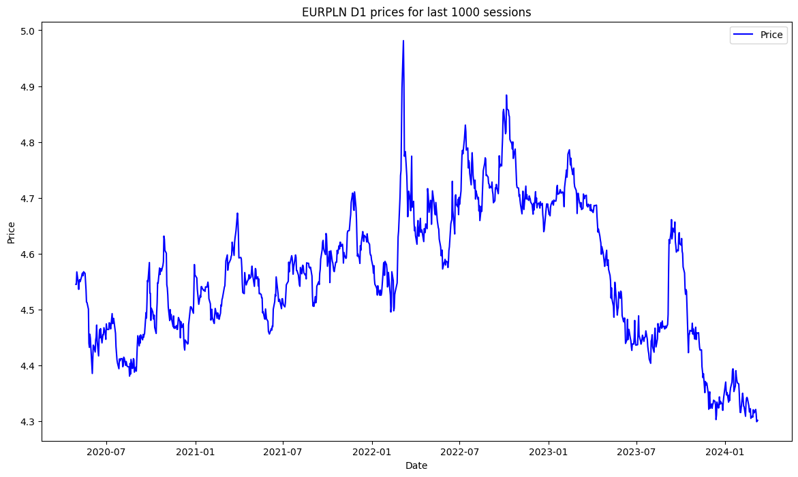

Wykres 7.

Cena EURPLN w interwale D1 w czasie 24.04.2020 – 08.03.2024 (1000 dni)

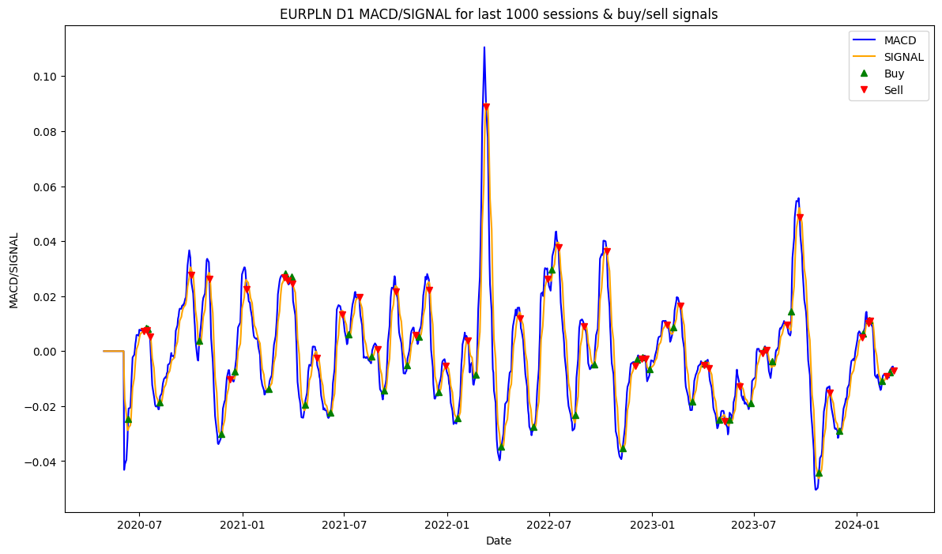

Wykres 8.

Linie MACD i SIGNAL dla EURPLN w interwale D1 wraz z zaznaczonymi sygnałami *BUY/SELL.*

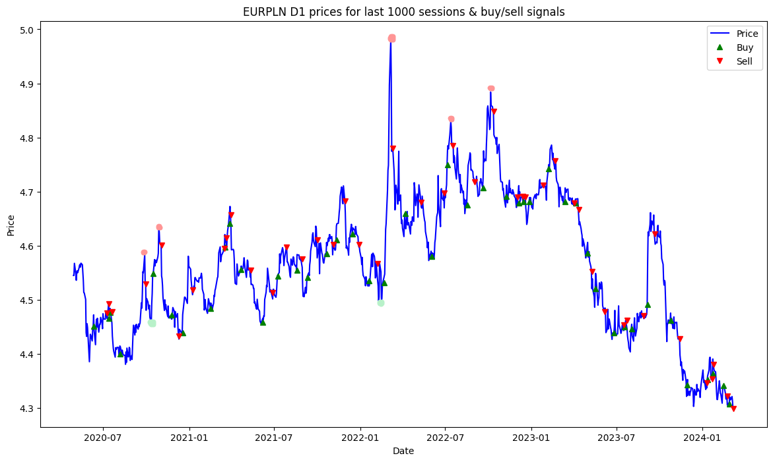

Wykres 9.

Cena EURPLN w interwale D1 wraz z zaznaczonymi sygnałami *BUY/SELL*.

Lepsze kupno:

1. 14.10.2020 r.
2. 9.02.2022 r.
3. 15.02.202 r.

Lepsza sprzedaż:

1. 28.09.2020 r.
2. 29.10.2020 r.
3. 7.03.2022 r.
4. 13.07.2023 r.
5. 8.10.2023 r.

Ochrona kapitału:

1. przełom października i listopada 2023 r.
2. druga połowa stycznia 2024 r. (niemalże identyczne ceny kupna i sprzedaży, chwilę później duży dołek)

|  |
| --- |
| =========================================================================================================================================================  Profit/loss report for EURPLN D1; transaction every BUY/SELL signal (at least D1 apart, if bought, need to be sold).  Buy date: 2020-06-11 | Buy price: 4.45 | Sell date: 2020-07-09 | Sell price: 4.48 | Profit: 24.19 0.543 % | Duration: 28 days 00:00:00  Buy date: 2020-07-13 | Buy price: 4.47 | Sell date: 2020-07-14 | Sell price: 4.49 | Profit: 27.34 0.612 % | Duration: 1 days 00:00:00  Buy date: 2020-07-16 | Buy price: 4.48 | Sell date: 2020-07-20 | Sell price: 4.48 | Profit: 1.73 0.039 % | Duration: 4 days 00:00:00  Buy date: 2020-08-06 | Buy price: 4.40 | Sell date: 2020-10-01 | Sell price: 4.53 | Profit: 128.79 2.927 % | Duration: 56 days 00:00:00  Buy date: 2020-10-16 | Buy price: 4.55 | Sell date: 2020-11-03 | Sell price: 4.60 | Profit: 52.70 1.159 % | Duration: 18 days 00:00:00  **Buy date: 2020-11-24 | Buy price: 4.47 | Sell date: 2020-12-10 | Sell price: 4.43 | Profit: -38.35 -0.858 % | Duration: 16 days 00:00:00**  Buy date: 2020-12-18 | Buy price: 4.44 | Sell date: 2021-01-08 | Sell price: 4.52 | Profit: 78.96 1.779 % | Duration: 21 days 00:00:00  Buy date: 2021-02-16 | Buy price: 4.48 | Sell date: 2021-03-17 | Sell price: 4.60 | Profit: 111.07 2.477 % | Duration: 29 days 00:00:00  Buy date: 2021-03-18 | Buy price: 4.60 | Sell date: 2021-03-22 | Sell price: 4.61 | Profit: 16.95 0.369 % | Duration: 4 days 00:00:00  Buy date: 2021-03-29 | Buy price: 4.64 | Sell date: 2021-03-31 | Sell price: 4.66 | Profit: 15.35 0.331 % | Duration: 2 days 00:00:00  **Buy date: 2021-04-22 | Buy price: 4.56 | Sell date: 2021-05-13 | Sell price: 4.55 | Profit: -1.20 -0.026 % | Duration: 21 days 00:00:00**  Buy date: 2021-06-07 | Buy price: 4.46 | Sell date: 2021-06-28 | Sell price: 4.51 | Profit: 54.72 1.227 % | Duration: 21 days 00:00:00  Buy date: 2021-07-09 | Buy price: 4.54 | Sell date: 2021-07-28 | Sell price: 4.60 | Profit: 53.50 1.177 % | Duration: 19 days 00:00:00  Buy date: 2021-08-19 | Buy price: 4.55 | Sell date: 2021-08-30 | Sell price: 4.58 | Profit: 20.94 0.460 % | Duration: 11 days 00:00:00  Buy date: 2021-09-10 | Buy price: 4.54 | Sell date: 2021-10-01 | Sell price: 4.61 | Profit: 68.40 1.506 % | Duration: 21 days 00:00:00  Buy date: 2021-10-21 | Buy price: 4.58 | Sell date: 2021-11-05 | Sell price: 4.60 | Profit: 17.45 0.381 % | Duration: 15 days 00:00:00  Buy date: 2021-11-11 | Buy price: 4.61 | Sell date: 2021-11-30 | Sell price: 4.68 | Profit: 71.38 1.548 % | Duration: 19 days 00:00:00  **Buy date: 2021-12-16 | Buy price: 4.62 | Sell date: 2021-12-29 | Sell price: 4.60 | Profit: -20.34 -0.440 % | Duration: 13 days 00:00:00**  Buy date: 2022-01-19 | Buy price: 4.53 | Sell date: 2022-02-07 | Sell price: 4.57 | Profit: 31.68 0.699 % | Duration: 19 days 00:00:00  Buy date: 2022-02-21 | Buy price: 4.53 | Sell date: 2022-03-11 | Sell price: 4.78 | Profit: 247.80 5.468 % | Duration: 18 days 00:00:00  Buy date: 2022-04-07 | Buy price: 4.66 | Sell date: 2022-05-11 | Sell price: 4.68 | Profit: 21.41 0.460 % | Duration: 34 days 00:00:00  Buy date: 2022-06-03 | Buy price: 4.58 | Sell date: 2022-06-29 | Sell price: 4.70 | Profit: 117.68 2.570 % | Duration: 26 days 00:00:00  Buy date: 2022-07-06 | Buy price: 4.75 | Sell date: 2022-07-18 | Sell price: 4.79 | Profit: 36.32 0.765 % | Duration: 12 days 00:00:00  Buy date: 2022-08-17 | Buy price: 4.68 | Sell date: 2022-09-02 | Sell price: 4.72 | Profit: 41.54 0.888 % | Duration: 16 days 00:00:00  Buy date: 2022-09-20 | Buy price: 4.71 | Sell date: 2022-10-12 | Sell price: 4.85 | Profit: 140.59 2.987 % | Duration: 22 days 00:00:00  **Buy date: 2022-11-09 | Buy price: 4.69 | Sell date: 2022-12-02 | Sell price: 4.69 | Profit: -0.38 -0.008 % | Duration: 23 days 00:00:00**  Buy date: 2022-12-05 | Buy price: 4.68 | Sell date: 2022-12-13 | Sell price: 4.69 | Profit: 12.45 0.266 % | Duration: 8 days 00:00:00  Buy date: 2022-12-15 | Buy price: 4.68 | Sell date: 2022-12-20 | Sell price: 4.69 | Profit: 8.37 0.179 % | Duration: 5 days 00:00:00  Buy date: 2022-12-28 | Buy price: 4.68 | Sell date: 2023-01-27 | Sell price: 4.71 | Profit: 30.22 0.646 % | Duration: 30 days 00:00:00  Buy date: 2023-02-07 | Buy price: 4.74 | Sell date: 2023-02-20 | Sell price: 4.76 | Profit: 14.42 0.304 % | Duration: 13 days 00:00:00  ***Buy date: 2023-03-14 | Buy price: 4.68 | Sell date: 2023-04-03 | Sell price: 4.68 | Profit: -1.92 -0.041 % | Duration: 20 days 00:00:00***  ***Buy date: 2023-04-05 | Buy price: 4.68 | Sell date: 2023-04-12 | Sell price: 4.67 | Profit: -11.44 -0.245 % | Duration: 7 days 00:00:00***  ***Buy date: 2023-05-01 | Buy price: 4.59 | Sell date: 2023-05-10 | Sell price: 4.55 | Profit: -34.74 -0.757 % | Duration: 9 days 00:00:00***  ***Buy date: 2023-05-18 | Buy price: 4.52 | Sell date: 2023-06-06 | Sell price: 4.48 | Profit: -42.08 -0.931 % | Duration: 19 days 00:00:00***  Buy date: 2023-06-26 | Buy price: 4.44 | Sell date: 2023-07-17 | Sell price: 4.45 | Profit: 15.61 0.352 % | Duration: 21 days 00:00:00  Buy date: 2023-07-19 | Buy price: 4.45 | Sell date: 2023-07-24 | Sell price: 4.46 | Profit: 12.15 0.273 % | Duration: 5 days 00:00:00  Buy date: 2023-08-03 | Buy price: 4.45 | Sell date: 2023-08-29 | Sell price: 4.47 | Profit: 23.49 0.528 % | Duration: 26 days 00:00:00  Buy date: 2023-09-06 | Buy price: 4.49 | Sell date: 2023-09-21 | Sell price: 4.62 | Profit: 129.96 2.894 % | Duration: 15 days 00:00:00  **Buy date: 2023-10-25 | Buy price: 4.46 | Sell date: 2023-11-14 | Sell price: 4.43 | Profit: -34.24 -0.767 % | Duration: 20 days 00:00:00**  Buy date: 2023-11-30 | Buy price: 4.34 | Sell date: 2024-01-10 | Sell price: 4.35 | Profit: 3.38 0.078 % | Duration: 41 days 00:00:00  *Buy date: 2024-01-12 | Buy price: 4.35 | Sell date: 2024-01-22 | Sell price: 4.35 | Profit: 0.93 0.021 % | Duration: 10 days 00:00:00*  *Buy date: 2024-01-23 | Buy price: 4.36 | Sell date: 2024-01-25 | Sell price: 4.38 | Profit: 16.92 0.388 % | Duration: 2 days 00:00:00*  **Buy date: 2024-02-15 | Buy price: 4.34 | Sell date: 2024-02-23 | Sell price: 4.32 | Profit: -18.91 -0.436 % | Duration: 8 days 00:00:00**  **Buy date: 2024-02-28 | Buy price: 4.31 | Sell date: 2024-03-07 | Sell price: 4.30 | Profit: -8.21 -0.191 % | Duration: 8 days 00:00:00**  =========================================================================================================================================================  Total earnings: 1436.58 generated using 4451 units of borrowed capital, which needs to be returned  Return on Investment ROI: -67.724% |

Zestawienie transakcji kupna/sprzedaży co sygnał, interwał D1

### EURPLN, W1

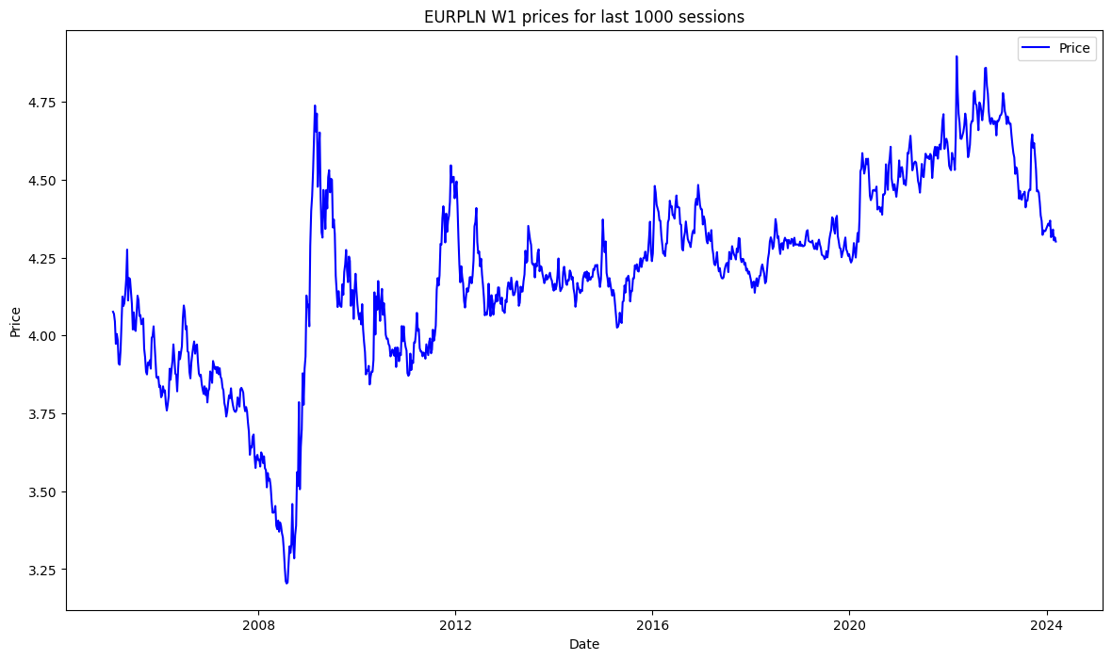

Wykres 10.

Cena EURPLN w interwale W1 w czasie 24.04.2020 – 08.03.2024 (1000 tygodni)

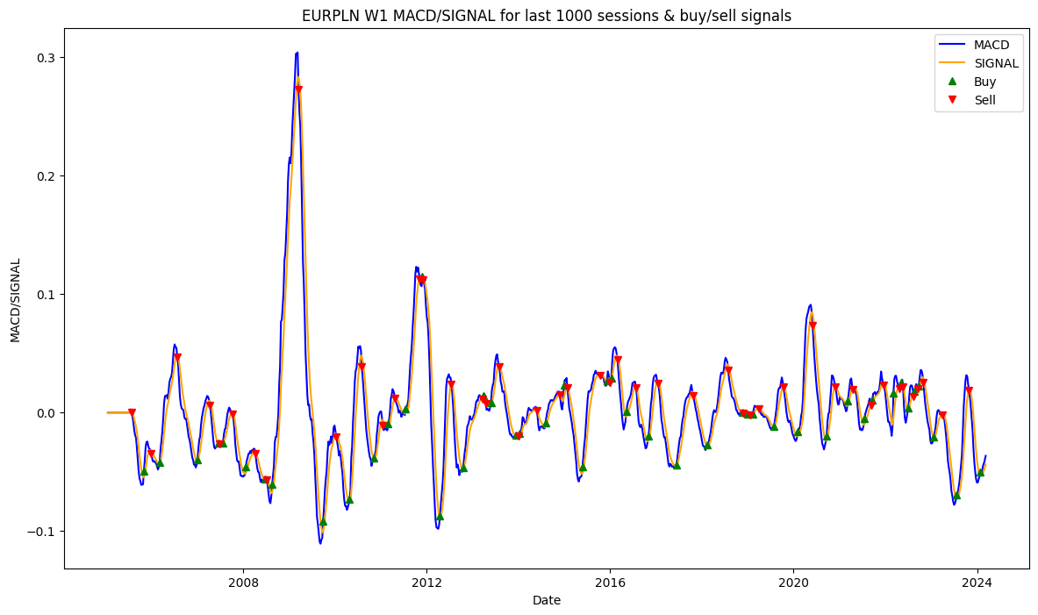

Wykres 11.

Linie MACD i SIGNAL dla EURPLN w interwale W1 wraz z zaznaczonymi sygnałami *BUY/SELL.*

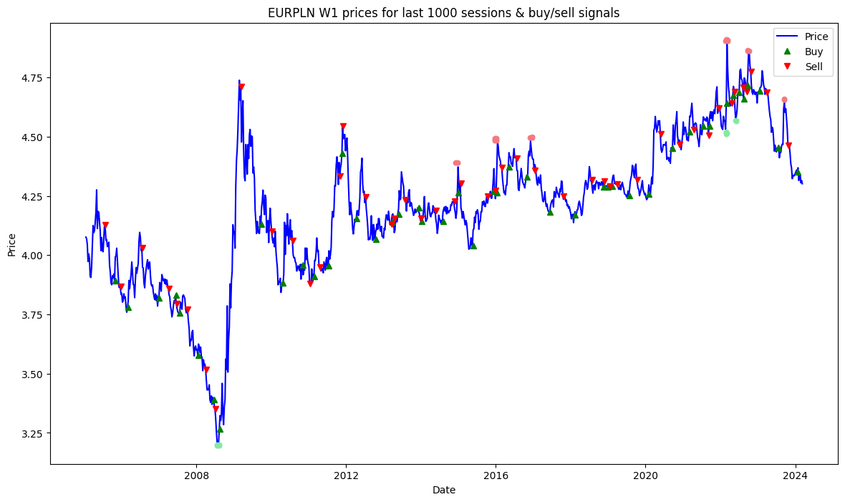

Wykres 12.

Cena EURPLN w interwale W1 wraz z zaznaczonymi sygnałami *BUY/SELL*.

|  |
| --- |
| =========================================================================================================================================================  Profit/loss report for EURPLN W1; transaction every BUY/SELL signal (at least W1 apart, if bought, need to be sold).  **Buy date: 2005-10-30 | Buy price: 3.89 | Sell date: 2005-12-25 | Sell price: 3.87 | Profit: -25.90 -0.665 % | Duration: 56 days 00:00:00**  Buy date: 2006-03-05 | Buy price: 3.78 | Sell date: 2006-07-23 | Sell price: 4.03 | Profit: 251.20 6.647 % | Duration: 140 days 00:00:00  Buy date: 2006-12-31 | Buy price: 3.82 | Sell date: 2007-04-08 | Sell price: 3.86 | Profit: 39.10 1.023 % | Duration: 98 days 00:00:00  **Buy date: 2007-06-17 | Buy price: 3.83 | Sell date: 2007-06-24 | Sell price: 3.80 | Profit: -34.50 -0.901 % | Duration: 7 days 00:00:00**  Buy date: 2007-07-22 | Buy price: 3.75 | Sell date: 2007-10-07 | Sell price: 3.77 | Profit: 15.70 0.418 % | Duration: 77 days 00:00:00  **Buy date: 2008-01-20 | Buy price: 3.58 | Sell date: 2008-04-06 | Sell price: 3.52 | Profit: -61.80 -1.727 % | Duration: 77 days 00:00:00**  **Buy date: 2008-06-22 | Buy price: 3.39 | Sell date: 2008-07-06 | Sell price: 3.35 | Profit: -37.70 -1.112 % | Duration: 14 days 00:00:00**  Buy date: 2008-08-17 | Buy price: 3.27 | Sell date: 2009-03-15 | Sell price: 4.71 | Profit: 1445.10 44.226 % | Duration: 210 days 00:00:00  Buy date: 2009-09-27 | Buy price: 4.13 | Sell date: 2010-01-10 | Sell price: 4.10 | Profit: -30.50 -0.738 % | Duration: 105 days 00:00:00  Buy date: 2010-04-25 | Buy price: 3.88 | Sell date: 2010-08-01 | Sell price: 4.06 | Profit: 178.00 4.583 % | Duration: 98 days 00:00:00  ***Buy date: 2010-11-07 | Buy price: 3.96 | Sell date: 2011-01-16 | Sell price: 3.88 | Profit: -81.30 -2.053 % | Duration: 70 days 00:00:00***  Buy date: 2011-02-27 | Buy price: 3.91 | Sell date: 2011-04-24 | Sell price: 3.95 | Profit: 37.50 0.959 % | Duration: 56 days 00:00:00  Buy date: 2011-07-17 | Buy price: 3.95 | Sell date: 2011-11-06 | Sell price: 4.33 | Profit: 377.80 9.553 % | Duration: 112 days 00:00:00  Buy date: 2011-11-27 | Buy price: 4.43 | Sell date: 2011-12-04 | Sell price: 4.55 | Profit: 117.10 2.644 % | Duration: 7 days 00:00:00  Buy date: 2012-04-15 | Buy price: 4.16 | Sell date: 2012-07-15 | Sell price: 4.25 | Profit: 91.70 2.207 % | Duration: 91 days 00:00:00  Buy date: 2012-10-14 | Buy price: 4.07 | Sell date: 2013-03-17 | Sell price: 4.13 | Profit: 63.00 1.549 % | Duration: 154 days 00:00:00  Buy date: 2013-03-24 | Buy price: 4.14 | Sell date: 2013-04-14 | Sell price: 4.16 | Profit: 16.00 0.386 % | Duration: 21 days 00:00:00  Buy date: 2013-05-26 | Buy price: 4.17 | Sell date: 2013-07-28 | Sell price: 4.23 | Profit: 58.00 1.389 % | Duration: 63 days 00:00:00  ***Buy date: 2013-12-08 | Buy price: 4.20 | Sell date: 2013-12-29 | Sell price: 4.16 | Profit: -46.20 -1.100 % | Duration: 21 days 00:00:00***  Buy date: 2014-01-05 | Buy price: 4.14 | Sell date: 2014-05-25 | Sell price: 4.19 | Profit: 43.70 1.055 % | Duration: 140 days 00:00:00  Buy date: 2014-08-03 | Buy price: 4.14 | Sell date: 2014-11-23 | Sell price: 4.23 | Profit: 84.90 2.050 % | Duration: 112 days 00:00:00  Buy date: 2014-12-28 | Buy price: 4.26 | Sell date: 2015-01-25 | Sell price: 4.30 | Profit: 38.30 0.898 % | Duration: 28 days 00:00:00  Buy date: 2015-05-24 | Buy price: 4.04 | Sell date: 2015-10-11 | Sell price: 4.25 | Profit: 207.60 5.138 % | Duration: 140 days 00:00:00  Buy date: 2015-12-06 | Buy price: 4.27 | Sell date: 2015-12-27 | Sell price: 4.27 | Profit: 2.22 0.052 % | Duration: 21 days 00:00:00  Buy date: 2016-01-10 | Buy price: 4.26 | Sell date: 2016-02-28 | Sell price: 4.37 | Profit: 106.29 2.493 % | Duration: 49 days 00:00:00  Buy date: 2016-05-08 | Buy price: 4.37 | Sell date: 2016-07-24 | Sell price: 4.41 | Profit: 37.19 0.850 % | Duration: 77 days 00:00:00  Buy date: 2016-10-30 | Buy price: 4.33 | Sell date: 2017-01-15 | Sell price: 4.36 | Profit: 26.26 0.606 % | Duration: 77 days 00:00:00  Buy date: 2017-06-11 | Buy price: 4.18 | Sell date: 2017-10-22 | Sell price: 4.25 | Profit: 65.80 1.573 % | Duration: 133 days 00:00:00  Buy date: 2018-02-11 | Buy price: 4.17 | Sell date: 2018-07-29 | Sell price: 4.32 | Profit: 149.60 3.588 % | Duration: 168 days 00:00:00  Buy date: 2018-11-18 | Buy price: 4.29 | Sell date: 2018-11-25 | Sell price: 4.31 | Profit: 25.85 0.603 % | Duration: 7 days 00:00:00  Buy date: 2018-12-30 | Buy price: 4.29 | Sell date: 2019-01-20 | Sell price: 4.29 | Profit: 3.24 0.076 % | Duration: 21 days 00:00:00  Buy date: 2019-02-10 | Buy price: 4.29 | Sell date: 2019-03-31 | Sell price: 4.30 | Profit: 8.80 0.205 % | Duration: 49 days 00:00:00  Buy date: 2019-07-28 | Buy price: 4.25 | Sell date: 2019-10-13 | Sell price: 4.32 | Profit: 68.53 1.612 % | Duration: 77 days 00:00:00  Buy date: 2020-02-02 | Buy price: 4.26 | Sell date: 2020-05-31 | Sell price: 4.51 | Profit: 254.61 5.979 % | Duration: 119 days 00:00:00  Buy date: 2020-09-20 | Buy price: 4.45 | Sell date: 2020-11-29 | Sell price: 4.47 | Profit: 14.49 0.325 % | Duration: 70 days 00:00:00  Buy date: 2021-03-07 | Buy price: 4.52 | Sell date: 2021-04-18 | Sell price: 4.53 | Profit: 9.81 0.217 % | Duration: 42 days 00:00:00  ***Buy date: 2021-07-18 | Buy price: 4.55 | Sell date: 2021-09-12 | Sell price: 4.51 | Profit: -40.34 -0.887 % | Duration: 56 days 00:00:00***  Buy date: 2021-09-19 | Buy price: 4.54 | Sell date: 2021-12-19 | Sell price: 4.62 | Profit: 76.51 1.684 % | Duration: 91 days 00:00:00  Buy date: 2022-03-06 | Buy price: 4.64 | Sell date: 2022-04-24 | Sell price: 4.64 | Profit: 2.16 0.047 % | Duration: 49 days 00:00:00  Buy date: 2022-05-08 | Buy price: 4.67 | Sell date: 2022-05-22 | Sell price: 4.69 | Profit: 17.49 0.374 % | Duration: 14 days 00:00:00  Buy date: 2022-07-03 | Buy price: 4.69 | Sell date: 2022-08-14 | Sell price: 4.71 | Profit: 19.75 0.421 % | Duration: 42 days 00:00:00  Buy date: 2022-08-21 | Buy price: 4.66 | Sell date: 2022-09-18 | Sell price: 4.69 | Profit: 31.89 0.684 % | Duration: 28 days 00:00:00  Buy date: 2022-09-25 | Buy price: 4.72 | Sell date: 2022-10-30 | Sell price: 4.78 | Profit: 57.93 1.228 % | Duration: 35 days 00:00:00  **Buy date: 2023-01-22 | Buy price: 4.69 | Sell date: 2023-04-02 | Sell price: 4.69 | Profit: -5.84 -0.124 % | Duration: 70 days 00:00:00**  Buy date: 2023-07-23 | Buy price: 4.45 | Sell date: 2023-10-29 | Sell price: 4.46 | Profit: 8.64 0.194 % | Duration: 98 days 00:00:00  =========================================================================================================================================================  Total earnings: 3687.68 generated using 3894 units of borrowed capital, which needs to be returned  Return on Investment ROI: -5.289% |

Zestawienie transakcji kupna/sprzedaży co sygnał, interwał W1

### S&P500, D1

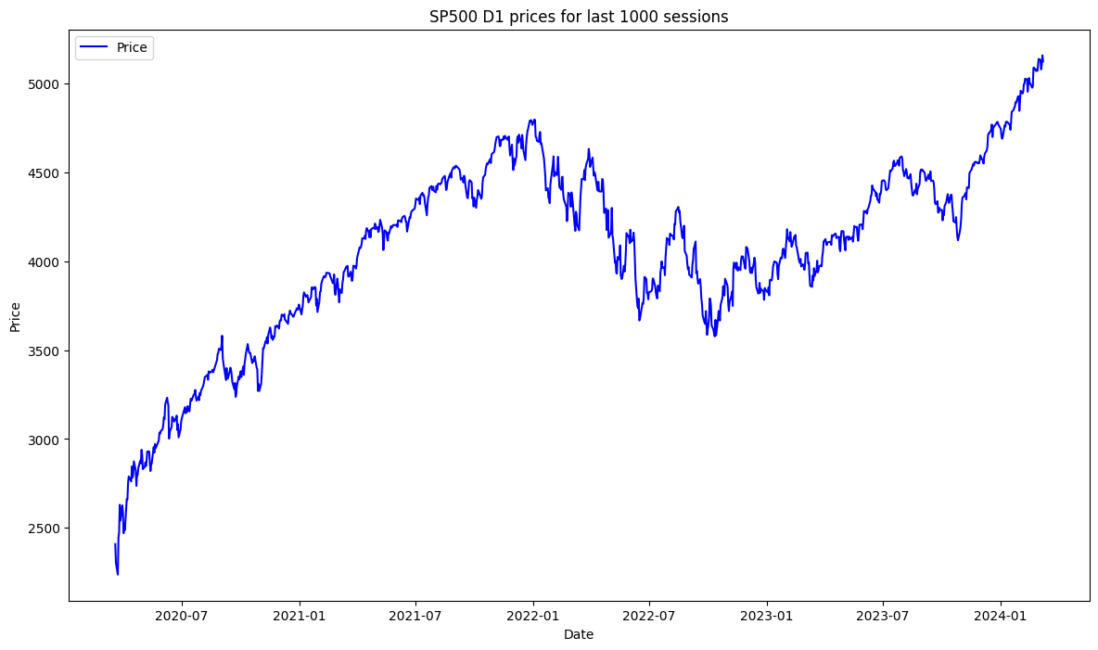

Wykres 13.

Cena S&P500 w interwale D1 w czasie 19.03.2020 – 08.03.2024 (1000 dni)

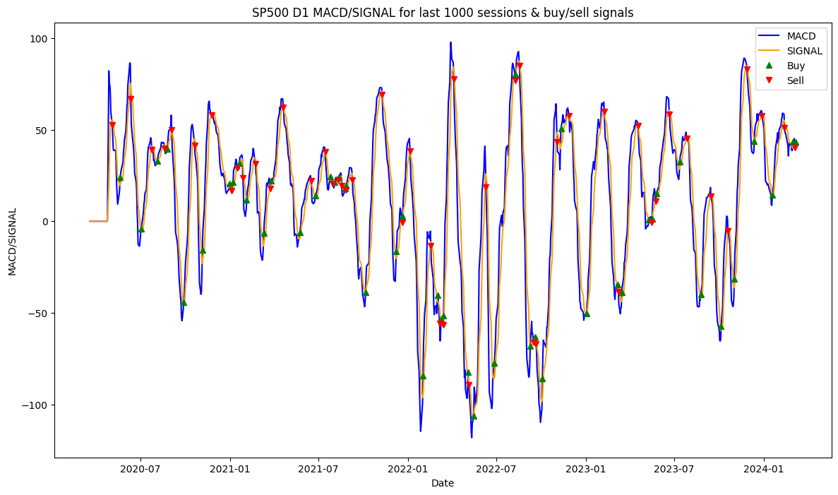

Wykres 14.

Linie MACD i SIGNAL dla S&P500 w interwale D1 wraz z zaznaczonymi sygnałami *BUY/SELL.*

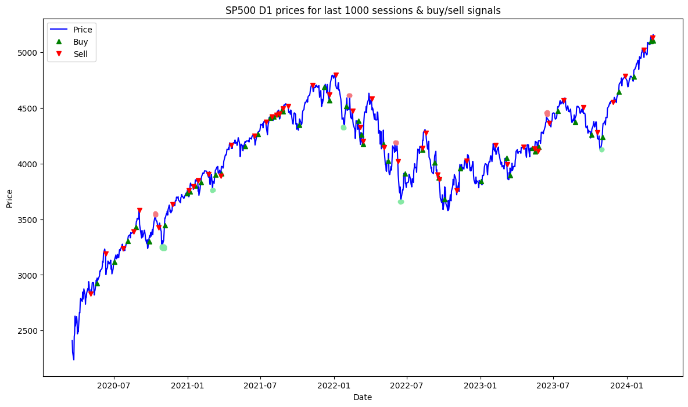

Wykres 15.

Cena S&P500 w interwale D1 wraz z zaznaczonymi sygnałami *BUY/SELL*.

Lepsze kupno:

1. 01.11.2020 r.
2. 05.03.2021 r.
3. 27.01.2022 r.
4. 15.06.2022 r.
5. 27.10.2023 r.

Lepsza sprzedaż:

1. 12.10.2020 r.
2. 01.02.2022 r.
3. 09.02.2022 r.
4. 06.08.2022 r.
5. 15.06.2023 r.

Ochrona kapitału:

1. Niemożliwe do określenia, straty niewielkie a sytuacja na wykresie niewskazująca na taką konieczność.

Uwaga: dla rynku rozgrywanego technicznie, z niedużym elementem spekulacji obserwujemy lepsze działanie wskaźnika; straty bardzo małe oraz duża ilość sygnałów. Bardzo mało sytuacji, w których sygnał SELL nie jest w bardzo bliskich okolicach szczytu.

|  |
| --- |
| =========================================================================================================================================================  Profit/loss report for SP500 D1; transaction every BUY/SELL signal (at least D1 apart, if bought, need to be sold).  Buy date: 2020-05-20 | Buy price: 2922.94 | Sell date: 2020-06-11 | Sell price: 3190.14 | Profit: 267200.00 9.141 % | Duration: 22 days 00:00:00  Buy date: 2020-07-02 | Buy price: 3115.86 | Sell date: 2020-07-24 | Sell price: 3235.66 | Profit: 119800.00 3.845 % | Duration: 22 days 00:00:00  Buy date: 2020-08-05 | Buy price: 3306.51 | Sell date: 2020-08-19 | Sell price: 3389.78 | Profit: 83270.00 2.518 % | Duration: 14 days 00:00:00  Buy date: 2020-08-25 | Buy price: 3431.28 | Sell date: 2020-09-03 | Sell price: 3580.84 | Profit: 149560.00 4.359 % | Duration: 9 days 00:00:00  Buy date: 2020-09-28 | Buy price: 3298.46 | Sell date: 2020-10-20 | Sell price: 3426.92 | Profit: 128460.00 3.895 % | Duration: 22 days 00:00:00  Buy date: 2020-11-05 | Buy price: 3443.44 | Sell date: 2020-11-25 | Sell price: 3635.41 | Profit: 191970.00 5.575 % | Duration: 20 days 00:00:00  Buy date: 2020-12-31 | Buy price: 3732.04 | Sell date: 2021-01-04 | Sell price: 3756.07 | Profit: 24030.00 0.644 % | Duration: 4 days 00:00:00  Buy date: 2021-01-07 | Buy price: 3748.14 | Sell date: 2021-01-15 | Sell price: 3795.54 | Profit: 47400.00 1.265 % | Duration: 8 days 00:00:00  Buy date: 2021-01-20 | Buy price: 3798.91 | Sell date: 2021-01-27 | Sell price: 3849.62 | Profit: 50710.00 1.335 % | Duration: 7 days 00:00:00  Buy date: 2021-02-04 | Buy price: 3830.17 | Sell date: 2021-02-22 | Sell price: 3906.71 | Profit: 76540.00 1.998 % | Duration: 18 days 00:00:00  **Buy date: 2021-03-11 | Buy price: 3898.81 | Sell date: 2021-03-25 | Sell price: 3889.14 | Profit: -9670.00 -0.248 % | Duration: 14 days 00:00:00**  Buy date: 2021-03-26 | Buy price: 3909.52 | Sell date: 2021-04-20 | Sell price: 4163.26 | Profit: 253740.00 6.490 % | Duration: 25 days 00:00:00  Buy date: 2021-05-24 | Buy price: 4155.86 | Sell date: 2021-06-16 | Sell price: 4246.59 | Profit: 90730.00 2.183 % | Duration: 23 days 00:00:00  Buy date: 2021-06-25 | Buy price: 4266.49 | Sell date: 2021-07-15 | Sell price: 4374.30 | Profit: 107810.00 2.527 % | Duration: 20 days 00:00:00  Buy date: 2021-07-26 | Buy price: 4411.79 | Sell date: 2021-07-30 | Sell price: 4419.15 | Profit: 7360.00 0.167 % | Duration: 4 days 00:00:00  Buy date: 2021-08-04 | Buy price: 4423.15 | Sell date: 2021-08-11 | Sell price: 4436.75 | Profit: 13600.00 0.307 % | Duration: 7 days 00:00:00  Buy date: 2021-08-12 | Buy price: 4442.41 | Sell date: 2021-08-18 | Sell price: 4448.08 | Profit: 5670.00 0.128 % | Duration: 6 days 00:00:00  Buy date: 2021-08-25 | Buy price: 4486.23 | Sell date: 2021-08-26 | Sell price: 4496.19 | Profit: 9960.00 0.222 % | Duration: 1 days 00:00:00  Buy date: 2021-08-27 | Buy price: 4470.00 | Sell date: 2021-09-09 | Sell price: 4514.07 | Profit: 44070.00 0.986 % | Duration: 13 days 00:00:00  Buy date: 2021-10-06 | Buy price: 4345.72 | Sell date: 2021-11-09 | Sell price: 4701.70 | Profit: 355980.00 8.192 % | Duration: 34 days 00:00:00  **Buy date: 2021-12-08 | Buy price: 4686.75 | Sell date: 2021-12-20 | Sell price: 4620.64 | Profit: -66110.00 -1.411 % | Duration: 12 days 00:00:00**  Buy date: 2021-12-21 | Buy price: 4568.02 | Sell date: 2022-01-05 | Sell price: 4793.54 | Profit: 225520.00 4.937 % | Duration: 15 days 00:00:00  **Buy date: 2022-02-01 | Buy price: 4515.55 | Sell date: 2022-02-17 | Sell price: 4475.01 | Profit: -40540.00 -0.898 % | Duration: 16 days 00:00:00**  **Buy date: 2022-03-03 | Buy price: 4386.54 | Sell date: 2022-03-07 | Sell price: 4328.87 | Profit: -57670.00 -1.315 % | Duration: 4 days 00:00:00**  **Buy date: 2022-03-11 | Buy price: 4259.52 | Sell date: 2022-03-14 | Sell price: 4204.31 | Profit: -55210.00 -1.296 % | Duration: 3 days 00:00:00**  Buy date: 2022-03-15 | Buy price: 4173.11 | Sell date: 2022-04-05 | Sell price: 4582.64 | Profit: 409530.00 9.814 % | Duration: 21 days 00:00:00  **Buy date: 2022-05-04 | Buy price: 4175.48 | Sell date: 2022-05-06 | Sell price: 4146.87 | Profit: -28610.00 -0.685 % | Duration: 2 days 00:00:00**  **Buy date: 2022-05-16 | Buy price: 4023.89 | Sell date: 2022-06-10 | Sell price: 4017.82 | Profit: -6070.00 -0.151 % | Duration: 25 days 00:00:00**  Buy date: 2022-06-27 | Buy price: 3911.74 | Sell date: 2022-08-09 | Sell price: 4140.06 | Profit: 228320.00 5.837 % | Duration: 43 days 00:00:00  Buy date: 2022-08-10 | Buy price: 4122.47 | Sell date: 2022-08-18 | Sell price: 4274.04 | Profit: 151570.00 3.677 % | Duration: 8 days 00:00:00  **Buy date: 2022-09-09 | Buy price: 4006.18 | Sell date: 2022-09-16 | Sell price: 3901.35 | Profit: -104830.00 -2.617 % | Duration: 7 days 00:00:00**  **Buy date: 2022-09-19 | Buy price: 3873.33 | Sell date: 2022-09-21 | Sell price: 3855.93 | Profit: -17400.00 -0.449 % | Duration: 2 days 00:00:00**  Buy date: 2022-10-04 | Buy price: 3678.43 | Sell date: 2022-11-03 | Sell price: 3759.69 | Profit: 81260.00 2.209 % | Duration: 30 days 00:00:00  Buy date: 2022-11-11 | Buy price: 3956.37 | Sell date: 2022-11-28 | Sell price: 4026.12 | Profit: 69750.00 1.763 % | Duration: 17 days 00:00:00  Buy date: 2023-01-03 | Buy price: 3839.50 | Sell date: 2023-02-08 | Sell price: 4164.00 | Profit: 324500.00 8.452 % | Duration: 36 days 00:00:00  **Buy date: 2023-03-07 | Buy price: 4048.42 | Sell date: 2023-03-09 | Sell price: 3992.01 | Profit: -56410.00 -1.393 % | Duration: 2 days 00:00:00**  Buy date: 2023-03-16 | Buy price: 3891.93 | Sell date: 2023-04-18 | Sell price: 4151.32 | Profit: 259390.00 6.665 % | Duration: 33 days 00:00:00  **Buy date: 2023-05-11 | Buy price: 4137.64 | Sell date: 2023-05-16 | Sell price: 4136.28 | Profit: -1360.00 -0.033 % | Duration: 5 days 00:00:00**  Buy date: 2023-05-17 | Buy price: 4109.90 | Sell date: 2023-05-25 | Sell price: 4115.24 | Profit: 5340.00 0.130 % | Duration: 8 days 00:00:00  Buy date: 2023-05-26 | Buy price: 4151.28 | Sell date: 2023-06-22 | Sell price: 4365.69 | Profit: 214410.00 5.165 % | Duration: 27 days 00:00:00  Buy date: 2023-07-13 | Buy price: 4472.16 | Sell date: 2023-07-27 | Sell price: 4566.75 | Profit: 94590.00 2.115 % | Duration: 14 days 00:00:00  Buy date: 2023-08-25 | Buy price: 4376.31 | Sell date: 2023-09-15 | Sell price: 4505.10 | Profit: 128790.00 2.943 % | Duration: 21 days 00:00:00  Buy date: 2023-10-06 | Buy price: 4258.19 | Sell date: 2023-10-20 | Sell price: 4278.00 | Profit: 19810.00 0.465 % | Duration: 14 days 00:00:00  Buy date: 2023-11-02 | Buy price: 4237.86 | Sell date: 2023-11-28 | Sell price: 4550.43 | Profit: 312570.00 7.376 % | Duration: 26 days 00:00:00  Buy date: 2023-12-13 | Buy price: 4643.70 | Sell date: 2023-12-29 | Sell price: 4783.35 | Profit: 139650.00 3.007 % | Duration: 16 days 00:00:00  Buy date: 2024-01-19 | Buy price: 4780.94 | Sell date: 2024-02-13 | Sell price: 5021.84 | Profit: 240900.00 5.039 % | Duration: 25 days 00:00:00  Buy date: 2024-03-01 | Buy price: 5096.27 | Sell date: 2024-03-05 | Sell price: 5130.95 | Profit: 34680.00 0.680 % | Duration: 4 days 00:00:00  =========================================================================================================================================================  Total earnings: 4524560.0 generated using 2922940 units of borrowed capital, which needs to be returned  Return on Investment ROI: 54.795% |

Zestawienie transakcji kupna/sprzedaży co sygnał, interwał D1

### S&P500, W1

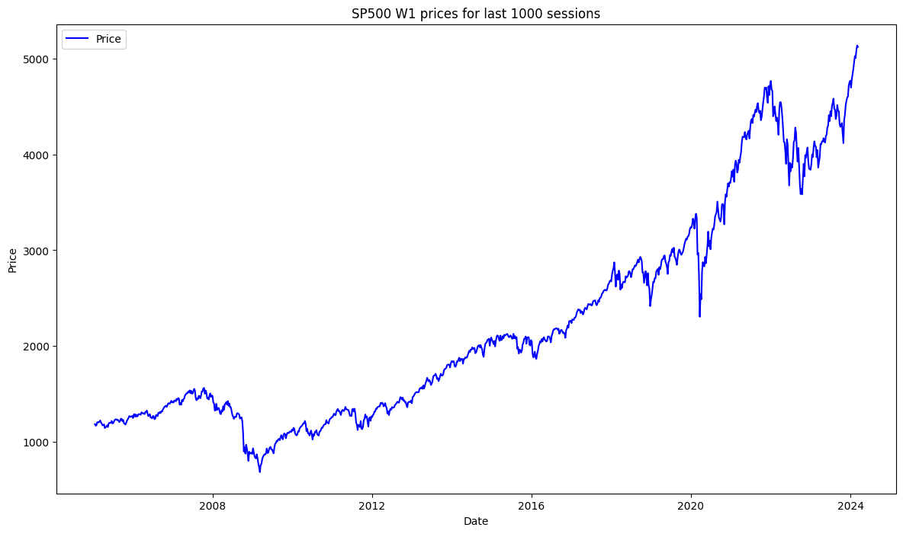

Wykres 16.

Cena S&P500 w interwale W1 w czasie 19.05.2005 – 08.03.2024 (1000 tygodni)

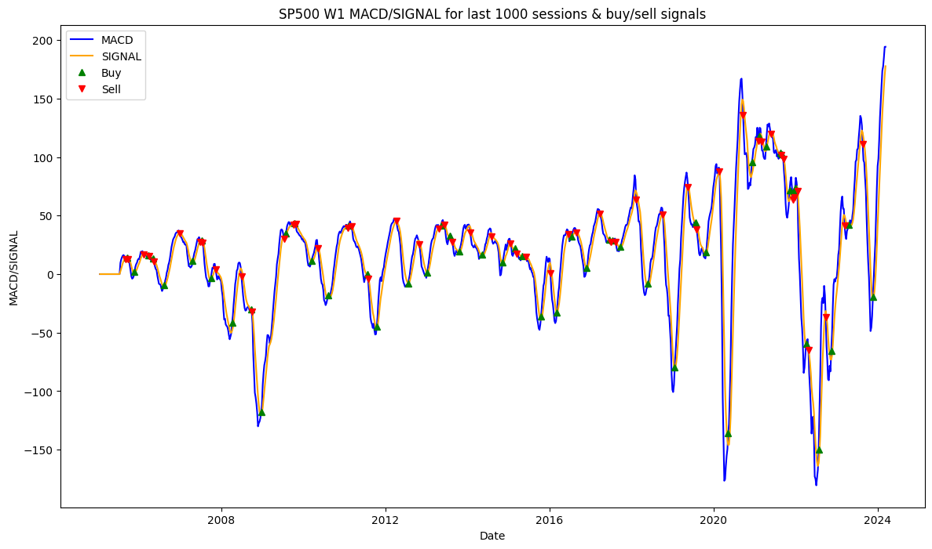

Wykres 17.

Linie MACD i SIGNAL dla S&P500 w interwale W1 wraz z zaznaczonymi sygnałami *BUY/SELL.*

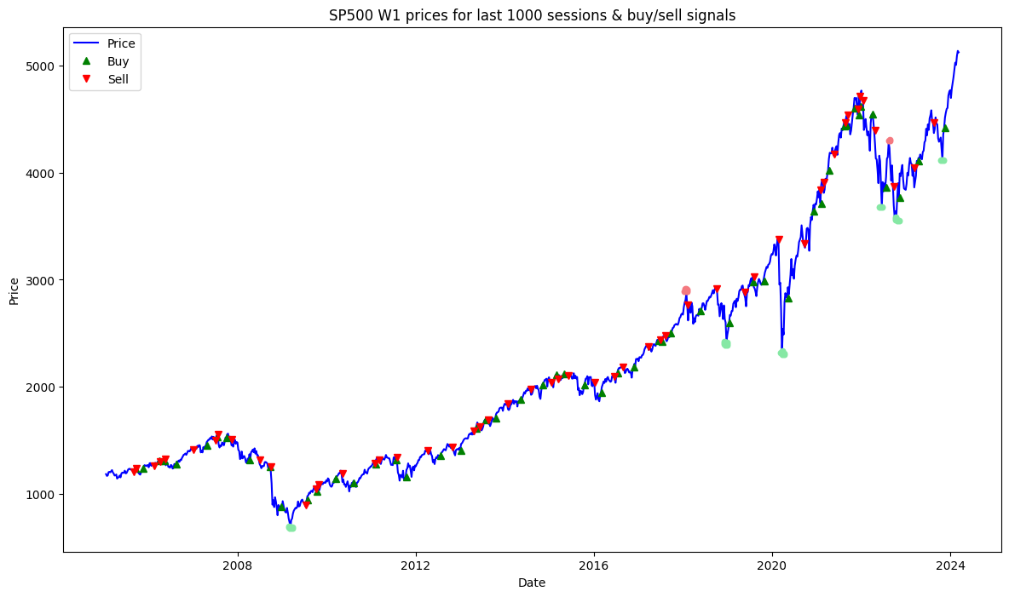

Wykres 18.

Cena S&P500 w interwale W1 wraz z zaznaczonymi sygnałami *BUY/SELL*.

|  |
| --- |
| =========================================================================================================================================================  Profit/loss report for SP500 W1; transaction every BUY/SELL signal (at least W1 apart, if bought, need to be sold).  **Buy date: 2005-09-18 | Buy price: 1241.48 | Sell date: 2005-09-25 | Sell price: 1237.91 | Profit: -3570.00 -0.288 % | Duration: 7 days 00:00:00**  Buy date: 2005-11-20 | Buy price: 1234.72 | Sell date: 2006-02-12 | Sell price: 1264.03 | Profit: 29310.00 2.374 % | Duration: 84 days 00:00:00  **Buy date: 2006-03-26 | Buy price: 1307.25 | Sell date: 2006-04-02 | Sell price: 1302.95 | Profit: -4300.00 -0.329 % | Duration: 7 days 00:00:00**  Buy date: 2006-05-07 | Buy price: 1310.61 | Sell date: 2006-05-14 | Sell price: 1325.76 | Profit: 15150.00 1.156 % | Duration: 7 days 00:00:00  Buy date: 2006-08-13 | Buy price: 1279.36 | Sell date: 2006-12-31 | Sell price: 1410.76 | Profit: 131400.00 10.271 % | Duration: 140 days 00:00:00  Buy date: 2007-04-22 | Buy price: 1452.85 | Sell date: 2007-07-01 | Sell price: 1502.56 | Profit: 49710.00 3.422 % | Duration: 70 days 00:00:00  Buy date: 2007-07-15 | Buy price: 1530.44 | Sell date: 2007-07-22 | Sell price: 1552.50 | Profit: 22060.00 1.441 % | Duration: 7 days 00:00:00  **Buy date: 2007-09-30 | Buy price: 1525.75 | Sell date: 2007-11-11 | Sell price: 1509.65 | Profit: -16100.00 -1.055 % | Duration: 42 days 00:00:00**  Buy date: 2008-04-06 | Buy price: 1315.22 | Sell date: 2008-06-29 | Sell price: 1317.93 | Profit: 2710.00 0.206 % | Duration: 84 days 00:00:00  Buy date: 2008-09-21 | Buy price: 1251.70 | Sell date: 2008-09-28 | Sell price: 1255.08 | Profit: 3380.00 0.270 % | Duration: 7 days 00:00:00  Buy date: 2008-12-21 | Buy price: 879.73 | Sell date: 2009-07-12 | Sell price: 896.42 | Profit: 16690.00 1.897 % | Duration: 203 days 00:00:00  Buy date: 2009-07-26 | Buy price: 940.38 | Sell date: 2009-10-04 | Sell price: 1044.38 | Profit: 104000.00 11.059 % | Duration: 70 days 00:00:00  Buy date: 2009-10-11 | Buy price: 1025.21 | Sell date: 2009-10-25 | Sell price: 1087.68 | Profit: 62470.00 6.093 % | Duration: 14 days 00:00:00  Buy date: 2010-03-14 | Buy price: 1138.70 | Sell date: 2010-05-09 | Sell price: 1186.69 | Profit: 47990.00 4.214 % | Duration: 56 days 00:00:00  Buy date: 2010-08-08 | Buy price: 1101.60 | Sell date: 2011-01-30 | Sell price: 1283.35 | Profit: 181750.00 16.499 % | Duration: 175 days 00:00:00  Buy date: 2011-02-06 | Buy price: 1276.34 | Sell date: 2011-03-06 | Sell price: 1319.88 | Profit: 43540.00 3.411 % | Duration: 28 days 00:00:00  Buy date: 2011-07-24 | Buy price: 1316.14 | Sell date: 2011-07-31 | Sell price: 1345.02 | Profit: 28880.00 2.194 % | Duration: 7 days 00:00:00  Buy date: 2011-10-16 | Buy price: 1155.46 | Sell date: 2012-04-08 | Sell price: 1408.47 | Profit: 253010.00 21.897 % | Duration: 175 days 00:00:00  Buy date: 2012-07-22 | Buy price: 1356.78 | Sell date: 2012-10-28 | Sell price: 1433.19 | Profit: 76410.00 5.632 % | Duration: 98 days 00:00:00  Buy date: 2013-01-06 | Buy price: 1402.43 | Sell date: 2013-04-21 | Sell price: 1588.85 | Profit: 186420.00 13.293 % | Duration: 105 days 00:00:00  Buy date: 2013-05-12 | Buy price: 1614.42 | Sell date: 2013-06-09 | Sell price: 1630.74 | Profit: 16320.00 1.011 % | Duration: 28 days 00:00:00  **Buy date: 2013-07-28 | Buy price: 1692.09 | Sell date: 2013-08-18 | Sell price: 1691.42 | Profit: -670.00 -0.040 % | Duration: 21 days 00:00:00**  Buy date: 2013-10-20 | Buy price: 1703.20 | Sell date: 2014-01-26 | Sell price: 1838.70 | Profit: 135500.00 7.956 % | Duration: 98 days 00:00:00  Buy date: 2014-05-11 | Buy price: 1881.14 | Sell date: 2014-08-03 | Sell price: 1978.34 | Profit: 97200.00 5.167 % | Duration: 84 days 00:00:00  Buy date: 2014-11-09 | Buy price: 2018.05 | Sell date: 2015-01-18 | Sell price: 2044.81 | Profit: 26760.00 1.326 % | Duration: 70 days 00:00:00  ***Buy date: 2015-03-01 | Buy price: 2110.30 | Sell date: 2015-03-15 | Sell price: 2071.26 | Profit: -39040.00 -1.850 % | Duration: 14 days 00:00:00***  **Buy date: 2015-05-03 | Buy price: 2117.69 | Sell date: 2015-06-07 | Sell price: 2107.39 | Profit: -10300.00 -0.486 % | Duration: 35 days 00:00:00**  Buy date: 2015-10-18 | Buy price: 2014.89 | Sell date: 2016-01-10 | Sell price: 2043.94 | Profit: 29050.00 1.442 % | Duration: 84 days 00:00:00  Buy date: 2016-03-06 | Buy price: 1948.05 | Sell date: 2016-06-19 | Sell price: 2096.07 | Profit: 148020.00 7.598 % | Duration: 105 days 00:00:00  Buy date: 2016-07-17 | Buy price: 2129.90 | Sell date: 2016-08-28 | Sell price: 2183.87 | Profit: 53970.00 2.534 % | Duration: 42 days 00:00:00  Buy date: 2016-11-27 | Buy price: 2181.90 | Sell date: 2017-03-26 | Sell price: 2378.25 | Profit: 196350.00 8.999 % | Duration: 119 days 00:00:00  Buy date: 2017-06-18 | Buy price: 2431.77 | Sell date: 2017-07-02 | Sell price: 2438.30 | Profit: 6530.00 0.269 % | Duration: 14 days 00:00:00  Buy date: 2017-07-16 | Buy price: 2425.18 | Sell date: 2017-08-13 | Sell price: 2476.83 | Profit: 51650.00 2.130 % | Duration: 28 days 00:00:00  Buy date: 2017-09-24 | Buy price: 2500.23 | Sell date: 2018-02-11 | Sell price: 2762.13 | Profit: 261900.00 10.475 % | Duration: 140 days 00:00:00  Buy date: 2018-05-27 | Buy price: 2712.97 | Sell date: 2018-10-07 | Sell price: 2913.98 | Profit: 201010.00 7.409 % | Duration: 133 days 00:00:00  Buy date: 2019-01-20 | Buy price: 2596.26 | Sell date: 2019-05-19 | Sell price: 2881.40 | Profit: 285140.00 10.983 % | Duration: 119 days 00:00:00  Buy date: 2019-07-28 | Buy price: 2976.61 | Sell date: 2019-08-04 | Sell price: 3025.86 | Profit: 49250.00 1.655 % | Duration: 7 days 00:00:00  Buy date: 2019-10-27 | Buy price: 2986.20 | Sell date: 2020-02-23 | Sell price: 3380.16 | Profit: 393960.00 13.193 % | Duration: 119 days 00:00:00  Buy date: 2020-05-10 | Buy price: 2830.71 | Sell date: 2020-09-20 | Sell price: 3340.97 | Profit: 510260.00 18.026 % | Duration: 133 days 00:00:00  Buy date: 2020-12-06 | Buy price: 3638.35 | Sell date: 2021-01-31 | Sell price: 3841.47 | Profit: 203120.00 5.583 % | Duration: 56 days 00:00:00  Buy date: 2021-02-07 | Buy price: 3714.24 | Sell date: 2021-02-28 | Sell price: 3906.71 | Profit: 192470.00 5.182 % | Duration: 21 days 00:00:00  Buy date: 2021-04-11 | Buy price: 4019.87 | Sell date: 2021-05-23 | Sell price: 4173.85 | Profit: 153980.00 3.830 % | Duration: 42 days 00:00:00  Buy date: 2021-08-15 | Buy price: 4436.52 | Sell date: 2021-08-22 | Sell price: 4468.00 | Profit: 31480.00 0.710 % | Duration: 7 days 00:00:00  Buy date: 2021-08-29 | Buy price: 4441.67 | Sell date: 2021-09-12 | Sell price: 4535.43 | Profit: 93760.00 2.111 % | Duration: 14 days 00:00:00  **Buy date: 2021-11-07 | Buy price: 4605.38 | Sell date: 2021-12-05 | Sell price: 4594.62 | Profit: -10760.00 -0.234 % | Duration: 28 days 00:00:00**  Buy date: 2021-12-12 | Buy price: 4538.43 | Sell date: 2021-12-19 | Sell price: 4712.02 | Profit: 173590.00 3.825 % | Duration: 7 days 00:00:00  Buy date: 2021-12-26 | Buy price: 4620.64 | Sell date: 2022-01-16 | Sell price: 4677.03 | Profit: 56390.00 1.220 % | Duration: 21 days 00:00:00  **Buy date: 2022-04-03 | Buy price: 4543.06 | Sell date: 2022-04-24 | Sell price: 4392.59 | Profit: -150470.00 -3.312 % | Duration: 21 days 00:00:00**  Buy date: 2022-07-24 | Buy price: 3863.16 | Sell date: 2022-09-25 | Sell price: 3873.33 | Profit: 10170.00 0.263 % | Duration: 63 days 00:00:00  Buy date: 2022-11-13 | Buy price: 3770.55 | Sell date: 2023-03-12 | Sell price: 4045.64 | Profit: 275090.00 7.296 % | Duration: 119 days 00:00:00  Buy date: 2023-04-16 | Buy price: 4105.02 | Sell date: 2023-08-20 | Sell price: 4464.05 | Profit: 359030.00 8.746 % | Duration: 126 days 00:00:00  =========================================================================================================================================================  Total earnings: 5031620.0 generated using 1241480 units of borrowed capital, which needs to be returned  Return on Investment ROI: 305.292% |

Zestawienie transakcji kupna/sprzedaży co sygnał, interwał W1

### Orlen Spółka Akcyjna, D1

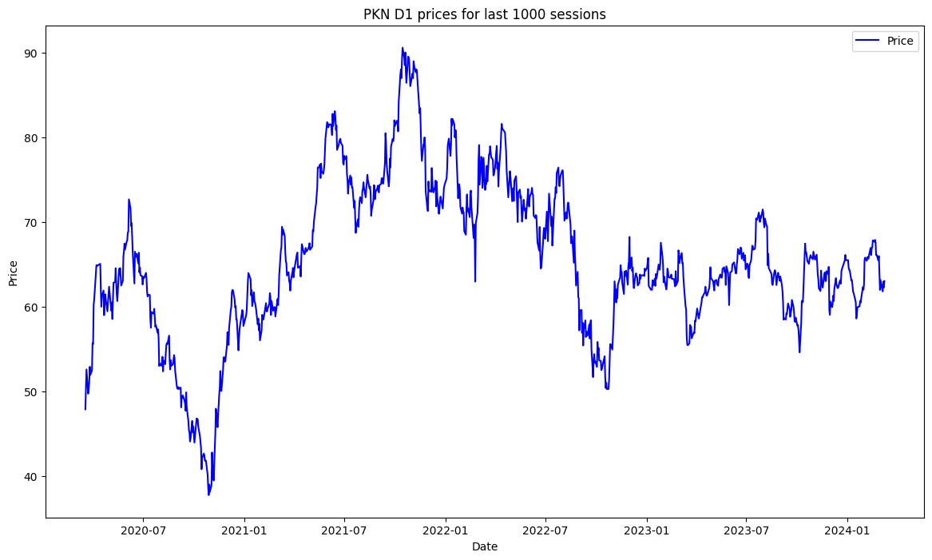

Wykres 19.

Cena Orlen Spółka Akcyjna w interwale D1 w czasie 11.05.2020 – 08.03.2024 (1000 sesji)

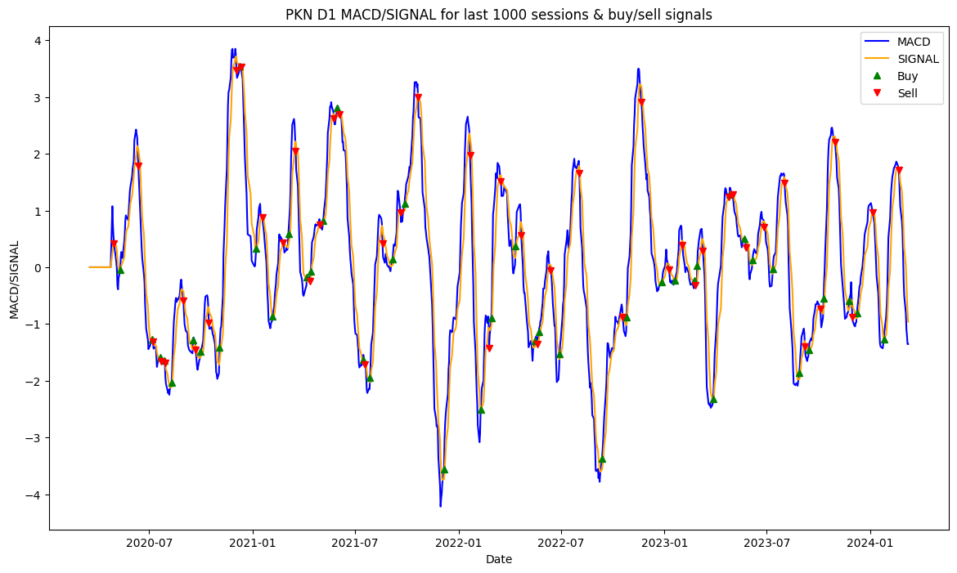

Wykres 20.

Linie MACD i SIGNAL dla Orlen Spółka Akcyjna w interwale D1 wraz z zaznaczonymi sygnałami *BUY/SELL.*

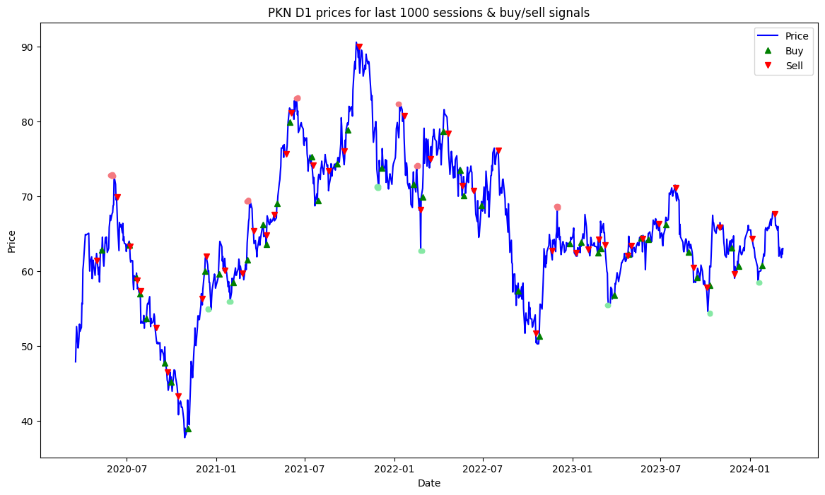

Wykres 21.

Cena Orlen Spółka Akcyjna w interwale D1 wraz z zaznaczonymi sygnałami *BUY/SELL*.

Lepsze kupno:

1. 21.12.2020 r.
2. 29.01.2021 r.
3. grudzień 2021 r.
4. 24.02.2022 r.
5. 16.03.2023 r.
6. 6.10.2023 r.
7. 17.01.2024 r.

Lepsza sprzedaż:

1. 5.06.2022 r.
2. 10.03.2021 r.
3. 14.06.2021 r.
4. pierwsza połowa stycznia 2022 r.
5. grudzień 2022 r.

Ochrona kapitału:

1. III i IV kwartał 2020 r., walor spada, MACD stara się kupować i nie tracić
2. wrzesień 2022 r.
3. listopad 2023 r.

|  |
| --- |
| =========================================================================================================================================================  Profit/loss report for PKN D1; transaction every BUY/SELL signal (at least D1 apart, if bought, need to be sold).  Buy date: 2020-05-11 | Buy price: 62.82 | Sell date: 2020-06-12 | Sell price: 69.88 | Profit: 7059.06 11.237 % | Duration: 32 days 00:00:00  ***Buy date: 2020-07-06 | Buy price: 63.44 | Sell date: 2020-07-08 | Sell price: 63.32 | Profit: -119.61 -0.189 % | Duration: 2 days 00:00:00***  ***Buy date: 2020-07-21 | Buy price: 59.18 | Sell date: 2020-07-23 | Sell price: 58.78 | Profit: -400.34 -0.676 % | Duration: 2 days 00:00:00***  Buy date: 2020-07-28 | Buy price: 56.94 | Sell date: 2020-07-29 | Sell price: 57.32 | Profit: 380.37 0.668 % | Duration: 1 days 00:00:00  ***Buy date: 2020-08-10 | Buy price: 53.64 | Sell date: 2020-08-31 | Sell price: 52.42 | Profit: -1219.79 -2.274 % | Duration: 21 days 00:00:00***  ***Buy date: 2020-09-17 | Buy price: 47.70 | Sell date: 2020-09-22 | Sell price: 46.50 | Profit: -1199.94 -2.516 % | Duration: 5 days 00:00:00***  ***Buy date: 2020-09-30 | Buy price: 45.16 | Sell date: 2020-10-15 | Sell price: 43.30 | Profit: -1859.88 -4.118 % | Duration: 15 days 00:00:00***  Buy date: 2020-11-03 | Buy price: 38.91 | Sell date: 2020-12-03 | Sell price: 56.32 | Profit: 17409.40 44.742 % | Duration: 30 days 00:00:00  Buy date: 2020-12-09 | Buy price: 60.00 | Sell date: 2020-12-11 | Sell price: 61.98 | Profit: 1980.65 3.301 % | Duration: 2 days 00:00:00  Buy date: 2021-01-07 | Buy price: 59.60 | Sell date: 2021-01-18 | Sell price: 60.06 | Profit: 460.13 0.772 % | Duration: 11 days 00:00:00  Buy date: 2021-02-05 | Buy price: 58.48 | Sell date: 2021-02-24 | Sell price: 59.72 | Profit: 1239.88 2.120 % | Duration: 19 days 00:00:00  Buy date: 2021-03-05 | Buy price: 61.48 | Sell date: 2021-03-18 | Sell price: 65.34 | Profit: 3860.39 6.279 % | Duration: 13 days 00:00:00  **Buy date: 2021-04-07 | Buy price: 66.20 | Sell date: 2021-04-13 | Sell price: 64.80 | Profit: -1399.52 -2.114 % | Duration: 6 days 00:00:00**  Buy date: 2021-04-14 | Buy price: 63.56 | Sell date: 2021-04-30 | Sell price: 67.50 | Profit: 3939.31 6.198 % | Duration: 16 days 00:00:00  Buy date: 2021-05-06 | Buy price: 69.06 | Sell date: 2021-05-25 | Sell price: 75.70 | Profit: 6640.64 9.616 % | Duration: 19 days 00:00:00  Buy date: 2021-05-31 | Buy price: 79.94 | Sell date: 2021-06-04 | Sell price: 81.18 | Profit: 1239.88 1.551 % | Duration: 4 days 00:00:00  **Buy date: 2021-07-15 | Buy price: 75.28 | Sell date: 2021-07-19 | Sell price: 74.12 | Profit: -1160.00 -1.541 % | Duration: 4 days 00:00:00**  Buy date: 2021-07-28 | Buy price: 69.44 | Sell date: 2021-08-19 | Sell price: 73.38 | Profit: 3939.98 5.674 % | Duration: 22 days 00:00:00  Buy date: 2021-09-06 | Buy price: 74.36 | Sell date: 2021-09-20 | Sell price: 76.08 | Profit: 1720.13 2.313 % | Duration: 14 days 00:00:00  Buy date: 2021-09-27 | Buy price: 78.90 | Sell date: 2021-10-21 | Sell price: 90.04 | Profit: 11139.97 14.119 % | Duration: 24 days 00:00:00  Buy date: 2021-12-06 | Buy price: 73.76 | Sell date: 2022-01-21 | Sell price: 80.76 | Profit: 7000.03 9.490 % | Duration: 46 days 00:00:00  **Buy date: 2022-02-09 | Buy price: 71.60 | Sell date: 2022-02-24 | Sell price: 68.20 | Profit: -3399.98 -4.749 % | Duration: 15 days 00:00:00**  Buy date: 2022-02-28 | Buy price: 69.86 | Sell date: 2022-03-16 | Sell price: 75.00 | Profit: 5139.92 7.357 % | Duration: 16 days 00:00:00  **Buy date: 2022-04-12 | Buy price: 78.70 | Sell date: 2022-04-22 | Sell price: 78.38 | Profit: -320.01 -0.407 % | Duration: 10 days 00:00:00**  **Buy date: 2022-05-16 | Buy price: 73.50 | Sell date: 2022-05-20 | Sell price: 71.40 | Profit: -2100.01 -2.857 % | Duration: 4 days 00:00:00**  Buy date: 2022-05-23 | Buy price: 70.06 | Sell date: 2022-06-13 | Sell price: 70.76 | Profit: 700.12 0.999 % | Duration: 21 days 00:00:00  Buy date: 2022-06-29 | Buy price: 68.76 | Sell date: 2022-08-03 | Sell price: 76.10 | Profit: 7340.05 10.675 % | Duration: 35 days 00:00:00  ***Buy date: 2022-09-12 | Buy price: 57.32 | Sell date: 2022-10-19 | Sell price: 51.68 | Profit: -5639.96 -9.839 % | Duration: 37 days 00:00:00***  Buy date: 2022-10-26 | Buy price: 51.26 | Sell date: 2022-11-21 | Sell price: 62.76 | Profit: 11500.04 22.435 % | Duration: 26 days 00:00:00  **Buy date: 2022-12-27 | Buy price: 63.70 | Sell date: 2023-01-09 | Sell price: 62.46 | Profit: -1240.02 -1.947 % | Duration: 13 days 00:00:00**  **Buy date: 2023-01-19 | Buy price: 63.86 | Sell date: 2023-02-02 | Sell price: 62.88 | Profit: -980.05 -1.535 % | Duration: 14 days 00:00:00**  Buy date: 2023-02-23 | Buy price: 62.40 | Sell date: 2023-02-24 | Sell price: 64.20 | Profit: 1800.03 2.885 % | Duration: 1 days 00:00:00  Buy date: 2023-02-28 | Buy price: 63.04 | Sell date: 2023-03-10 | Sell price: 63.48 | Profit: 440.02 0.698 % | Duration: 10 days 00:00:00  Buy date: 2023-03-28 | Buy price: 56.78 | Sell date: 2023-04-25 | Sell price: 62.02 | Profit: 5239.91 9.228 % | Duration: 28 days 00:00:00  Buy date: 2023-04-26 | Buy price: 62.23 | Sell date: 2023-05-02 | Sell price: 63.42 | Profit: 1190.06 1.912 % | Duration: 6 days 00:00:00  **Buy date: 2023-05-22 | Buy price: 64.47 | Sell date: 2023-05-25 | Sell price: 64.35 | Profit: -119.99 -0.186 % | Duration: 3 days 00:00:00**  Buy date: 2023-06-06 | Buy price: 64.20 | Sell date: 2023-06-27 | Sell price: 66.36 | Profit: 2159.90 3.364 % | Duration: 21 days 00:00:00  Buy date: 2023-07-12 | Buy price: 66.22 | Sell date: 2023-08-02 | Sell price: 71.10 | Profit: 4880.03 7.369 % | Duration: 21 days 00:00:00  **Buy date: 2023-08-28 | Buy price: 62.56 | Sell date: 2023-09-07 | Sell price: 60.50 | Profit: -2060.00 -3.293 % | Duration: 10 days 00:00:00**  **Buy date: 2023-09-14 | Buy price: 59.11 | Sell date: 2023-10-04 | Sell price: 57.84 | Profit: -1270.00 -2.149 % | Duration: 20 days 00:00:00**  Buy date: 2023-10-10 | Buy price: 58.10 | Sell date: 2023-10-30 | Sell price: 65.88 | Profit: 7780.00 13.391 % | Duration: 20 days 00:00:00  ***Buy date: 2023-11-24 | Buy price: 63.07 | Sell date: 2023-11-30 | Sell price: 59.60 | Profit: -3470.00 -5.502 % | Duration: 6 days 00:00:00***  Buy date: 2023-12-08 | Buy price: 60.66 | Sell date: 2024-01-05 | Sell price: 64.35 | Profit: 3690.00 6.083 % | Duration: 28 days 00:00:00  Buy date: 2024-01-25 | Buy price: 60.71 | Sell date: 2024-02-20 | Sell price: 67.67 | Profit: 6960.00 11.464 % | Duration: 26 days 00:00:00  =========================================================================================================================================================  Total earnings: 98870.78 generated using 62820 units of borrowed capital, which needs to be returned  Return on Investment ROI: 57.387% |

Zestawienie transakcji kupna/sprzedaży co sygnał, interwał D1

### Orlen Spółka Akcyjna, W1

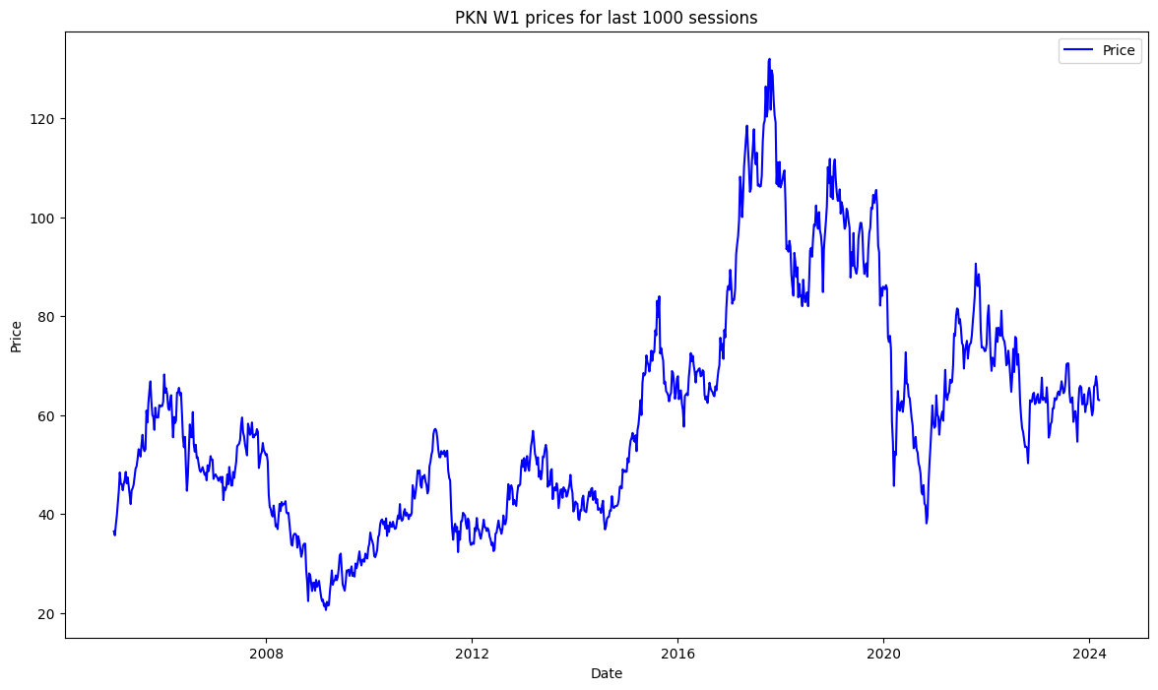

Wykres 22.

Cena Orlen Spółka Akcyjna w interwale W1 w czasie 08.01.2006 – 08.03.2024 (1000 tygodni)

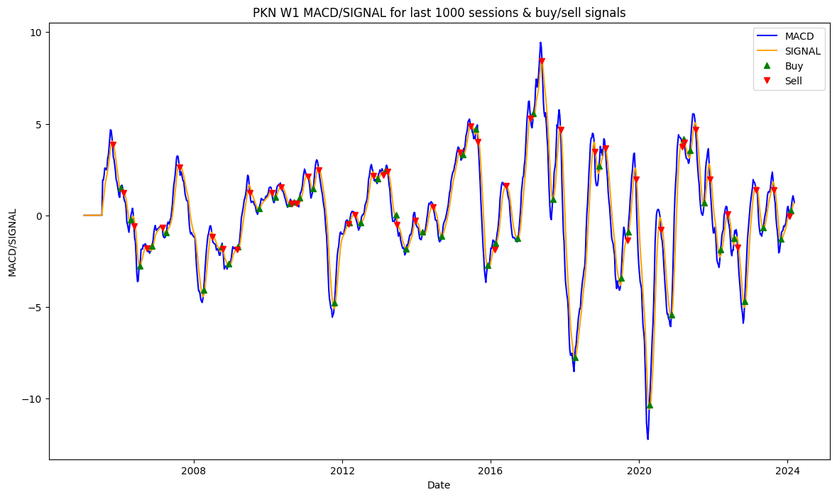

Wykres 23.

Linie MACD i SIGNAL dla Orlen Spółka Akcyjna w interwale W1 wraz z zaznaczonymi sygnałami *BUY/SELL.*

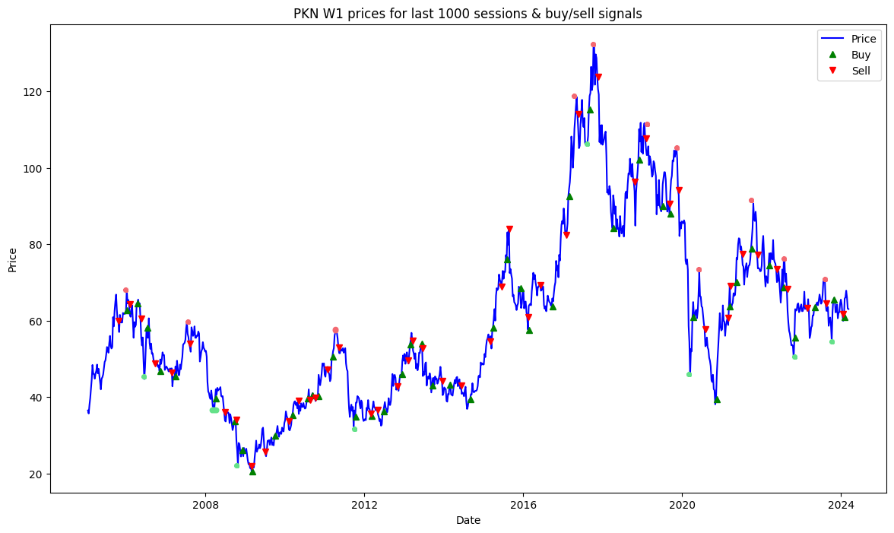

Wykres 21.

Cena Orlen Spółka Akcyjna w interwale W1 wraz z zaznaczonymi sygnałami *BUY/SELL*.

|  |
| --- |
| =========================================================================================================================================================  Profit/loss report for PKN W1; transaction every BUY/SELL signal (at least W1 apart, if bought, need to be sold).  Buy date: 2006-01-08 | Buy price: 62.70 | Sell date: 2006-02-05 | Sell price: 64.30 | Profit: 1600.66 2.553 % | Duration: 28 days 00:00:00  ***Buy date: 2006-04-16 | Buy price: 64.50 | Sell date: 2006-05-21 | Sell price: 60.50 | Profit: -3997.99 -6.198 % | Duration: 35 days 00:00:00***  ***Buy date: 2006-07-16 | Buy price: 58.10 | Sell date: 2006-09-24 | Sell price: 48.85 | Profit: -9250.80 -15.922% | Duration: 70 days 00:00:00***  **Buy date: 2006-11-12 | Buy price: 46.80 | Sell date: 2007-02-25 | Sell price: 46.41 | Profit: -391.50 -0.837 % | Duration: 105 days 00:00:00**  Buy date: 2007-04-01 | Buy price: 45.46 | Sell date: 2007-08-12 | Sell price: 54.00 | Profit: 8539.40 18.785 % | Duration: 133 days 00:00:00  ***Buy date: 2008-04-06 | Buy price: 39.57 | Sell date: 2008-06-29 | Sell price: 36.00 | Profit: -3571.50 -9.025 % | Duration: 84 days 00:00:00***  Buy date: 2008-09-28 | Buy price: 33.68 | Sell date: 2008-10-12 | Sell price: 34.00 | Profit: 320.36 0.951 % | Duration: 14 days 00:00:00  ***Buy date: 2008-12-07 | Buy price: 26.10 | Sell date: 2009-03-01 | Sell price: 21.85 | Profit: -4249.22 -16.281% | Duration: 84 days 00:00:00***  Buy date: 2009-03-08 | Buy price: 20.60 | Sell date: 2009-07-05 | Sell price: 25.77 | Profit: 5169.76 25.095 % | Duration: 119 days 00:00:00  Buy date: 2009-10-04 | Buy price: 29.99 | Sell date: 2010-02-07 | Sell price: 33.75 | Profit: 3759.58 12.536 % | Duration: 126 days 00:00:00  Buy date: 2010-03-14 | Buy price: 35.35 | Sell date: 2010-05-09 | Sell price: 39.11 | Profit: 3759.58 10.635 % | Duration: 56 days 00:00:00  **Buy date: 2010-08-01 | Buy price: 39.69 | Sell date: 2010-08-22 | Sell price: 39.15 | Profit: -542.94 -1.368 % | Duration: 21 days 00:00:00**  **Buy date: 2010-09-12 | Buy price: 40.40 | Sell date: 2010-10-10 | Sell price: 39.79 | Profit: -611.11 -1.513 % | Duration: 28 days 00:00:00**  Buy date: 2010-11-07 | Buy price: 40.21 | Sell date: 2011-01-30 | Sell price: 47.28 | Profit: 7069.59 17.582 % | Duration: 84 days 00:00:00  Buy date: 2011-03-20 | Buy price: 50.50 | Sell date: 2011-05-15 | Sell price: 52.95 | Profit: 2450.82 4.853 % | Duration: 56 days 00:00:00  Buy date: 2011-10-16 | Buy price: 34.80 | Sell date: 2012-03-04 | Sell price: 35.68 | Profit: 880.61 2.531 % | Duration: 140 days 00:00:00  Buy date: 2012-03-11 | Buy price: 35.00 | Sell date: 2012-05-06 | Sell price: 36.70 | Profit: 1700.93 4.860 % | Duration: 56 days 00:00:00  Buy date: 2012-07-01 | Buy price: 36.20 | Sell date: 2012-11-04 | Sell price: 42.85 | Profit: 6649.18 18.367 % | Duration: 126 days 00:00:00  Buy date: 2012-12-16 | Buy price: 46.01 | Sell date: 2013-02-10 | Sell price: 49.50 | Profit: 3489.93 7.585 % | Duration: 56 days 00:00:00  Buy date: 2013-03-03 | Buy price: 53.75 | Sell date: 2013-03-24 | Sell price: 54.75 | Profit: 1000.55 1.862 % | Duration: 21 days 00:00:00  **Buy date: 2013-06-16 | Buy price: 53.99 | Sell date: 2013-06-23 | Sell price: 52.70 | Profit: -1288.87 -2.387 % | Duration: 7 days 00:00:00**  Buy date: 2013-09-22 | Buy price: 43.10 | Sell date: 2013-12-22 | Sell price: 44.31 | Profit: 1207.38 2.801 % | Duration: 91 days 00:00:00  **Buy date: 2014-03-02 | Buy price: 43.15 | Sell date: 2014-06-15 | Sell price: 43.00 | Profit: -151.22 -0.350 % | Duration: 105 days 00:00:00**  Buy date: 2014-09-07 | Buy price: 39.43 | Sell date: 2015-03-08 | Sell price: 54.61 | Profit: 15180.13 38.499 % | Duration: 182 days 00:00:00  Buy date: 2015-04-05 | Buy price: 58.12 | Sell date: 2015-06-21 | Sell price: 68.80 | Profit: 10678.51 18.373 % | Duration: 77 days 00:00:00  Buy date: 2015-08-09 | Buy price: 76.14 | Sell date: 2015-08-30 | Sell price: 84.00 | Profit: 7859.47 10.323 % | Duration: 21 days 00:00:00  **Buy date: 2015-12-06 | Buy price: 68.50 | Sell date: 2016-02-14 | Sell price: 61.02 | Profit: -7480.47 -10.920% | Duration: 70 days 00:00:00**  Buy date: 2016-02-21 | Buy price: 57.64 | Sell date: 2016-06-05 | Sell price: 69.30 | Profit: 11659.94 20.229 % | Duration: 105 days 00:00:00  Buy date: 2016-09-25 | Buy price: 63.80 | Sell date: 2017-01-29 | Sell price: 82.50 | Profit: 18701.35 29.313 % | Duration: 126 days 00:00:00  Buy date: 2017-02-26 | Buy price: 92.50 | Sell date: 2017-05-21 | Sell price: 114.00 | Profit: 21499.58 23.243 % | Duration: 84 days 00:00:00  Buy date: 2017-09-03 | Buy price: 115.26 | Sell date: 2017-11-19 | Sell price: 123.81 | Profit: 8551.48 7.420 % | Duration: 77 days 00:00:00  Buy date: 2018-04-08 | Buy price: 84.12 | Sell date: 2018-10-21 | Sell price: 96.30 | Profit: 12181.86 14.482 % | Duration: 196 days 00:00:00  Buy date: 2018-12-02 | Buy price: 102.15 | Sell date: 2019-02-03 | Sell price: 107.64 | Profit: 5493.99 5.378 % | Duration: 63 days 00:00:00  Buy date: 2019-07-07 | Buy price: 89.98 | Sell date: 2019-09-08 | Sell price: 90.64 | Profit: 660.07 0.734 % | Duration: 63 days 00:00:00  Buy date: 2019-09-15 | Buy price: 87.96 | Sell date: 2019-12-01 | Sell price: 94.20 | Profit: 6238.93 7.093 % | Duration: 77 days 00:00:00  **Buy date: 2020-04-12 | Buy price: 60.86 | Sell date: 2020-08-02 | Sell price: 57.82 | Profit: -3039.70 -4.995 % | Duration: 112 days 00:00:00**  Buy date: 2020-11-15 | Buy price: 39.46 | Sell date: 2021-02-28 | Sell price: 60.68 | Profit: 21220.52 53.777 % | Duration: 105 days 00:00:00  Buy date: 2021-03-14 | Buy price: 63.76 | Sell date: 2021-03-21 | Sell price: 69.12 | Profit: 5359.75 8.406 % | Duration: 7 days 00:00:00  Buy date: 2021-05-16 | Buy price: 70.02 | Sell date: 2021-07-11 | Sell price: 77.42 | Profit: 7399.23 10.567 % | Duration: 56 days 00:00:00  **Buy date: 2021-10-03 | Buy price: 78.90 | Sell date: 2021-11-28 | Sell price: 77.22 | Profit: -1680.08 -2.129 % | Duration: 56 days 00:00:00**  **Buy date: 2022-03-13 | Buy price: 74.42 | Sell date: 2022-05-22 | Sell price: 73.50 | Profit: -919.98 -1.236 % | Duration: 70 days 00:00:00**  **Buy date: 2022-07-24 | Buy price: 68.70 | Sell date: 2022-08-28 | Sell price: 68.30 | Profit: -400.06 -0.582 % | Duration: 35 days 00:00:00**  Buy date: 2022-11-06 | Buy price: 55.54 | Sell date: 2023-02-26 | Sell price: 63.30 | Profit: 7760.01 13.972 % | Duration: 112 days 00:00:00  Buy date: 2023-05-07 | Buy price: 63.42 | Sell date: 2023-08-20 | Sell price: 64.57 | Profit: 1149.97 1.813 % | Duration: 105 days 00:00:00  **Buy date: 2023-10-29 | Buy price: 65.41 | Sell date: 2024-01-21 | Sell price: 61.65 | Profit: -3760.00 -5.748 % | Duration: 84 days 00:00:00**  =========================================================================================================================================================  Total earnings: 167857.66 generated using 62700 units of borrowed capital, which needs to be returned  Return on Investment ROI: 167.714% |

Zestawienie transakcji kupna/sprzedaży co sygnał, interwał D1

### Skumulowane zestawienie zysku/straty

|  |  |  |  |  |
| --- | --- | --- | --- | --- |
| Walor | Interwał | Zysk/strata [jedn.] | Kapitał początkowy [jedn.] | ROI [%] |
| WIG20 | D1 | 2711620.00 | 1639080.00 | 65.435 |
| WIG20 | W1 | 3957030.00 | 2596160.00 | 52.419 |
| EURPLN | D1 | 1436.58 | 4451.00 | -67.724 |
| EURPLN | W1 | 3687.68 | 3894.00 | -5.289 |
| S&P500 | D1 | 4524560.00 | 2922940.00 | 54.795 |
| S&P500 | W1 | 5031620.00 | 1241480.00 | 305.292 |
| Orlen Spółka Akcyjna | D1 | 98870.78 | 62820.00 | 57.387 |
| Orlen Spółka Akcyjna | W1 | 167857.66 | 62700.00 | 167.714 |

[jedn.] – jednostki

ROI – Return on Investment, stopa zwrotu z inwestycji

### Algorytm zakupów i jego ewaluacja

Do realizacji zakupów ww. walorów wykorzystano algorytm *słuchaj sygnału*. Niezwłocznie po wykryciu sygnału hipotetyczny pasjonat instrumentów finansowych może uzyskać spory przychód, ale tylko pod warunkiem, że inwestycje będą bardzo długoterminowe (nawet 1000 tygodni = ca. 19 lat). Jak można wywnioskować z danych w tabeli, im dłuższy czas inwestycji, tym lepszy wynik. Im walor spokojniejszy, tym mniejsza szansa na duży zysk. Pary walutowe nie są zyskowne, zwłaszcza w przeciągu ostatnich 1000 dni (rozregulowanie po pandemii iCOVID19 w latach 2020-2021, wojna na Ukrainie, wybory w Polsce). Potwierdza się też teza, że im walor jest bardziej rozgrywany technicznie niż spekulacyjnie, tym gęściej są wskaźniki (S&P500 vs PKN). Widać to chociażby po czasach trwania transakcji *BUY/SELL* pokazanym w ostatnich kolumnach zestawień zysków i strat.

### Podsumowanie

MACD na pewno nie nadaje się na inwestycje krótkoterminowe, może powodować znaczne straty, ma opóźnioną reakcję na zmianę zachowania rynku i waloru. Źle wykrywa ruchy spekulacyjne. Lepiej radzi sobie z akcjami niż parami walutowymi. Najlepsze działanie, gdy walor cechuje się dużą płynnością i brakiem gwałtownych ruchów. Inwestowanie tylko w oparciu o wskazania MACD jest strategią niepożądaną, dobrym ruchem jest używać wskaźnika MACD w towarzystwie innych narzędzi. Potwierdzają się obserwacje zawarte w sekcji Wnioski ogólne.